[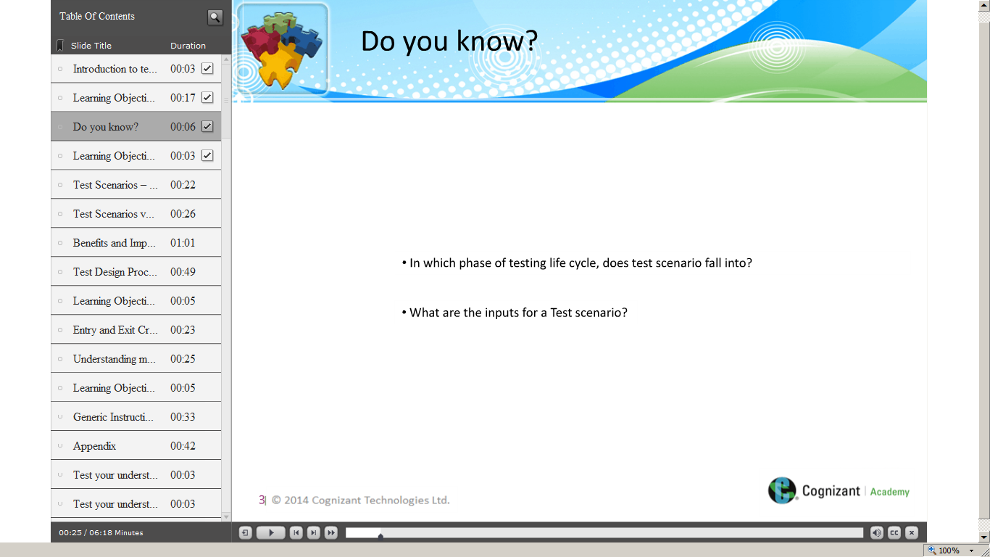](https://compass.learning.cognizant.com/elmprd/elearning/introduction_to_testsenarios_practitioner/introduction%20to%20test%20scenarios_practitioner.htm)

[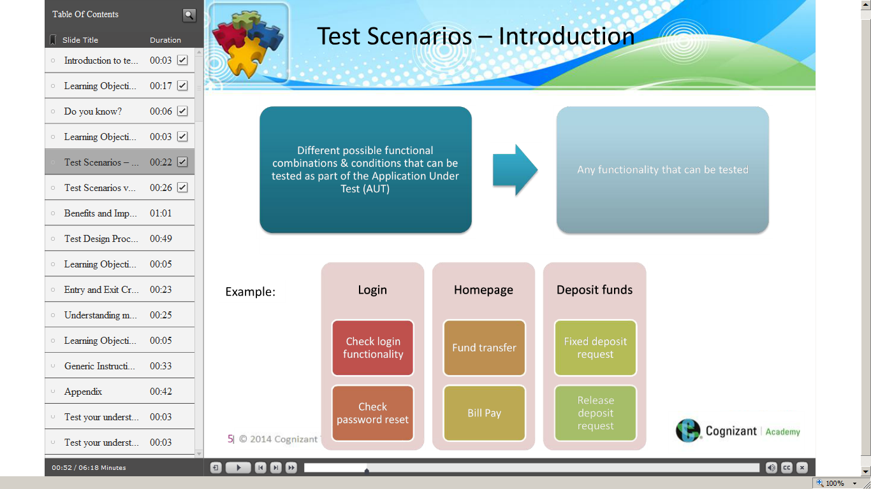](https://compass.learning.cognizant.com/elmprd/elearning/introduction_to_testsenarios_practitioner/introduction%20to%20test%20scenarios_practitioner.htm)

[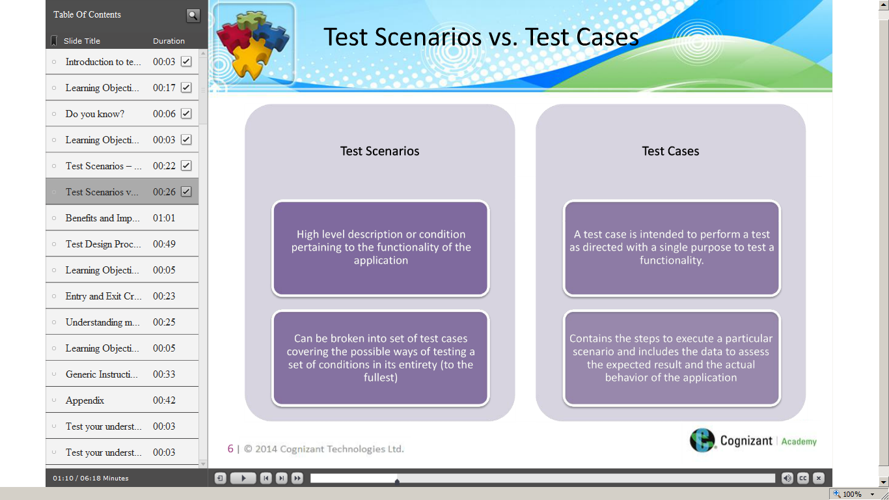](https://compass.learning.cognizant.com/elmprd/elearning/introduction_to_testsenarios_practitioner/introduction%20to%20test%20scenarios_practitioner.htm)

[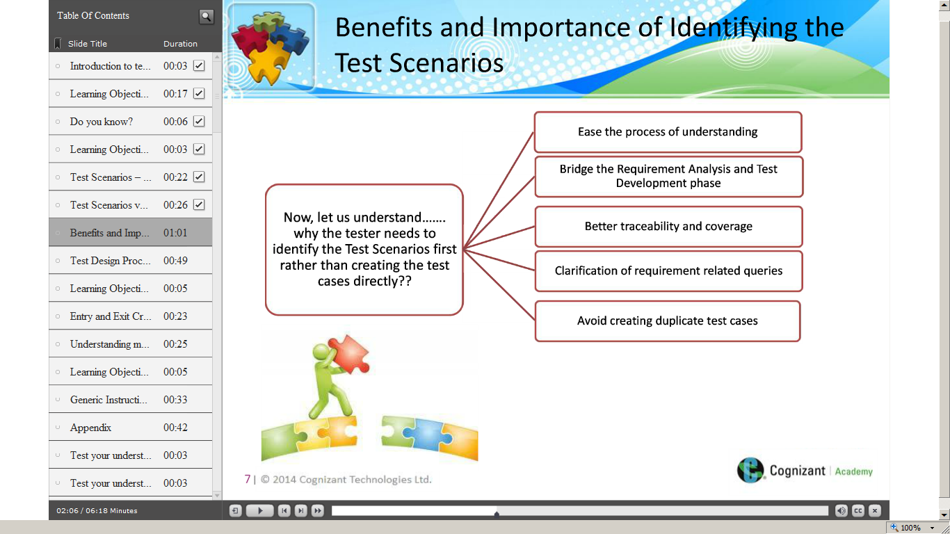](https://compass.learning.cognizant.com/elmprd/elearning/introduction_to_testsenarios_practitioner/introduction%20to%20test%20scenarios_practitioner.htm)

[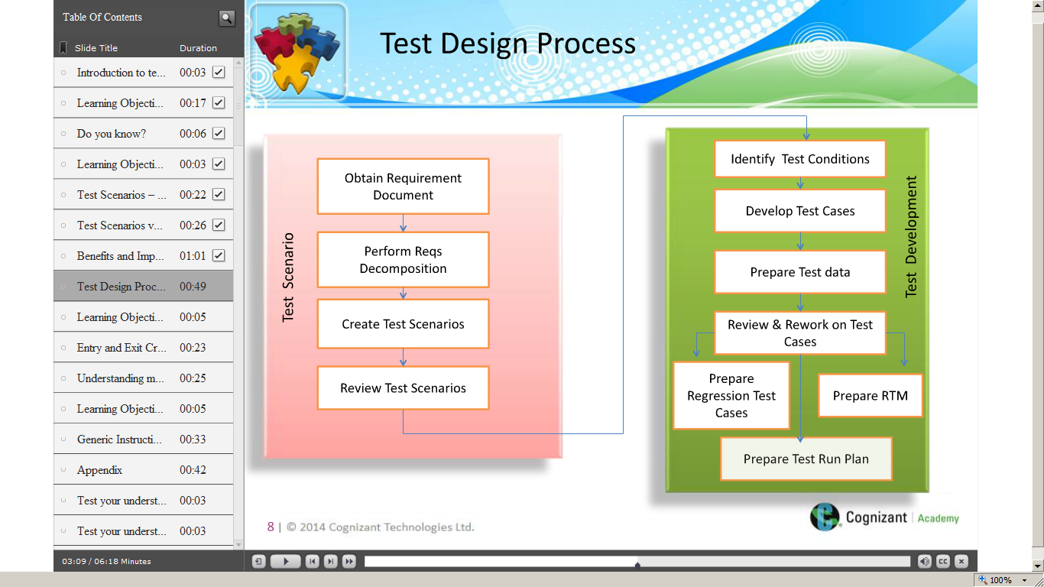](https://compass.learning.cognizant.com/elmprd/elearning/introduction_to_testsenarios_practitioner/introduction%20to%20test%20scenarios_practitioner.htm)

[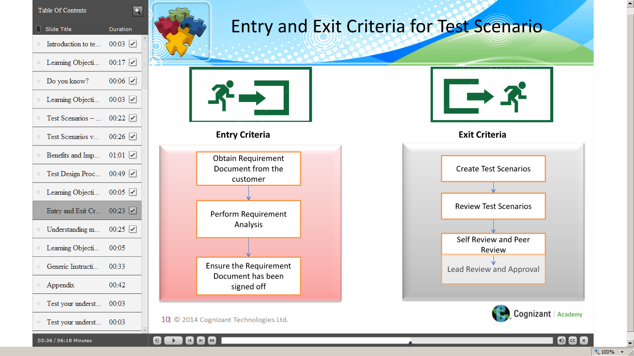](https://compass.learning.cognizant.com/elmprd/elearning/introduction_to_testsenarios_practitioner/introduction%20to%20test%20scenarios_practitioner.htm)

[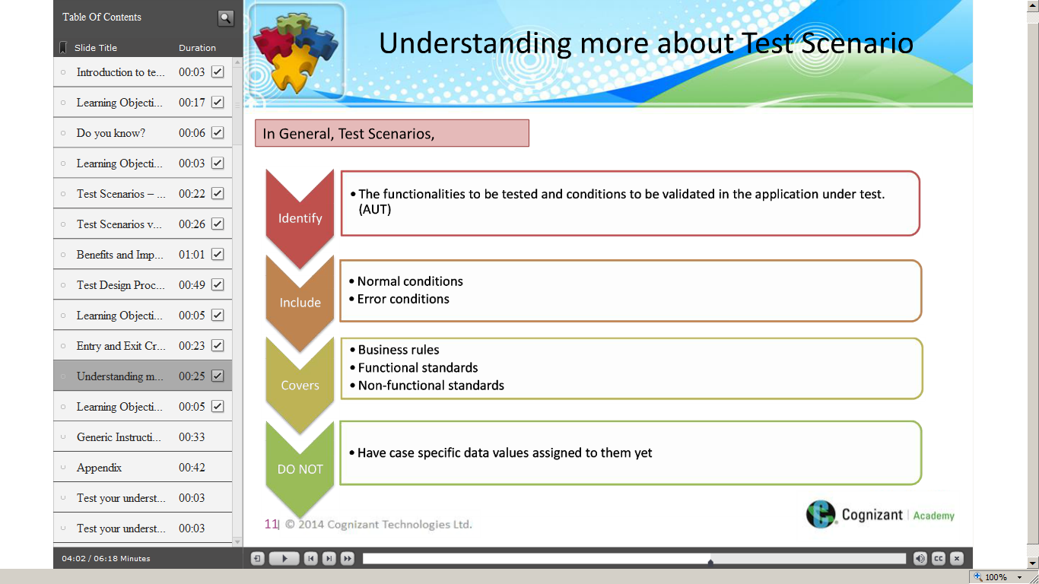](https://compass.learning.cognizant.com/elmprd/elearning/introduction_to_testsenarios_practitioner/introduction%20to%20test%20scenarios_practitioner.htm)

[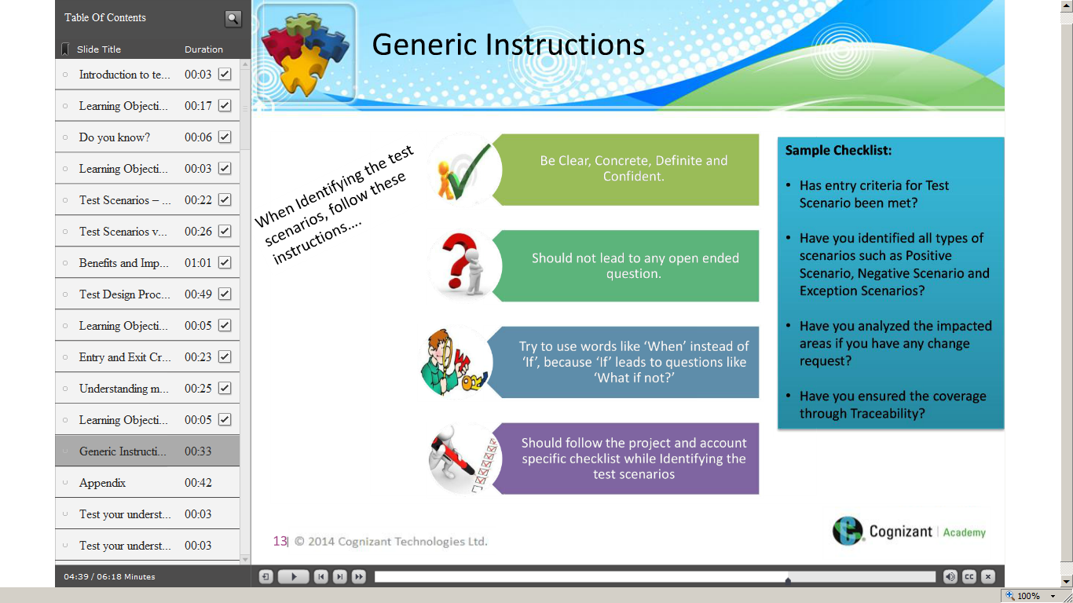](https://compass.learning.cognizant.com/elmprd/elearning/introduction_to_testsenarios_practitioner/introduction%20to%20test%20scenarios_practitioner.htm)

[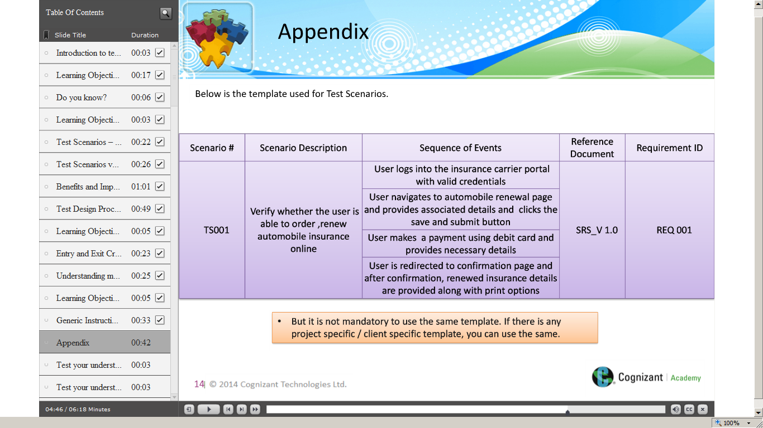](https://compass.learning.cognizant.com/elmprd/elearning/introduction_to_testsenarios_practitioner/introduction%20to%20test%20scenarios_practitioner.htm)

[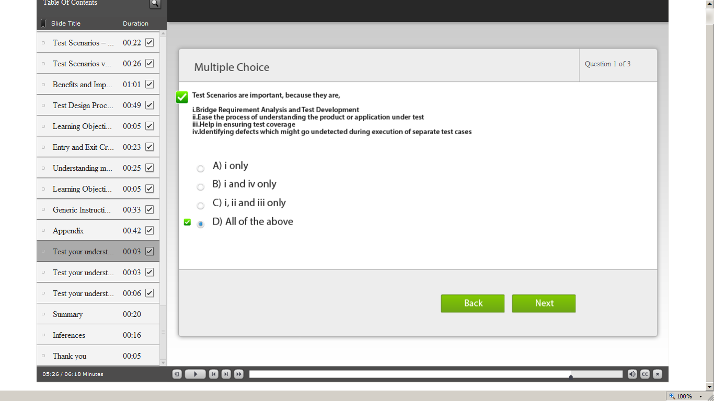](https://compass.learning.cognizant.com/elmprd/elearning/introduction_to_testsenarios_practitioner/introduction%20to%20test%20scenarios_practitioner.htm)

[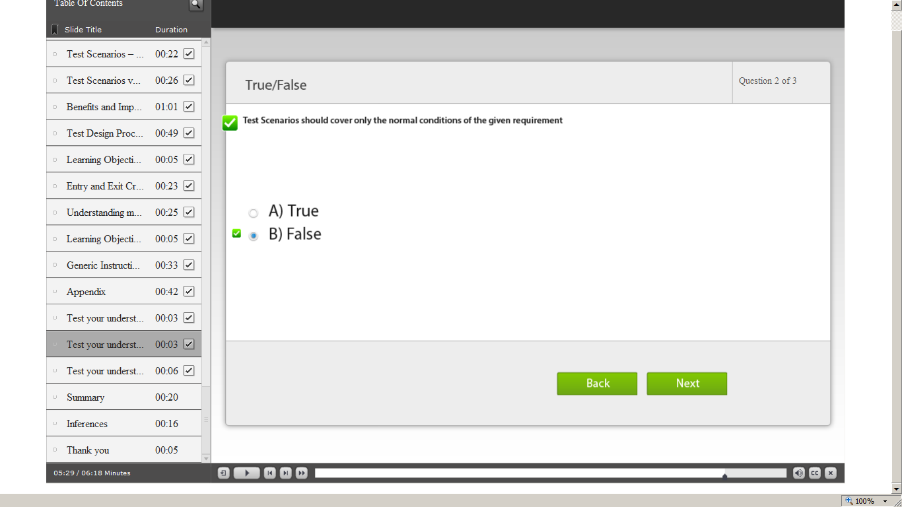](https://compass.learning.cognizant.com/elmprd/elearning/introduction_to_testsenarios_practitioner/introduction%20to%20test%20scenarios_practitioner.htm)

[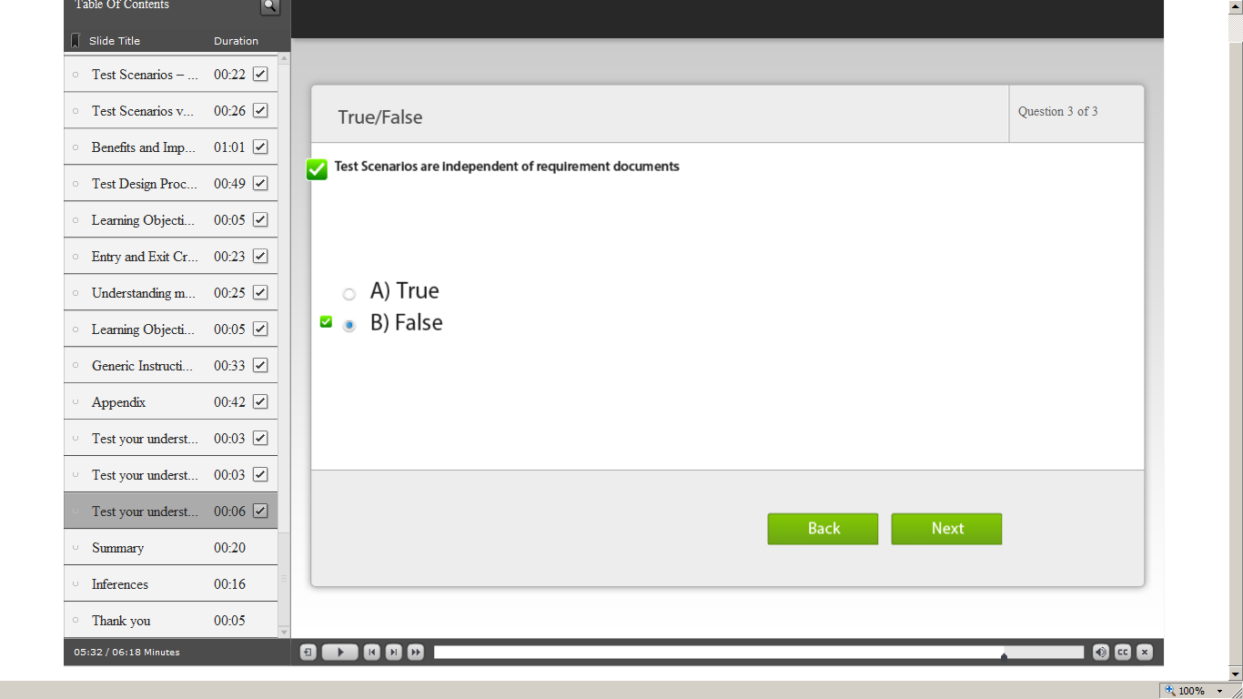](https://compass.learning.cognizant.com/elmprd/elearning/introduction_to_testsenarios_practitioner/introduction%20to%20test%20scenarios_practitioner.htm)

[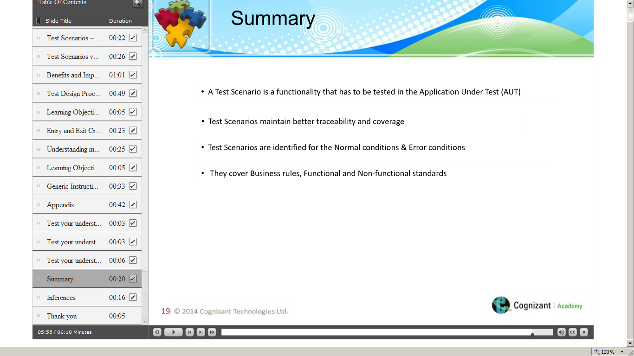](https://compass.learning.cognizant.com/elmprd/elearning/introduction_to_testsenarios_practitioner/introduction%20to%20test%20scenarios_practitioner.htm)

[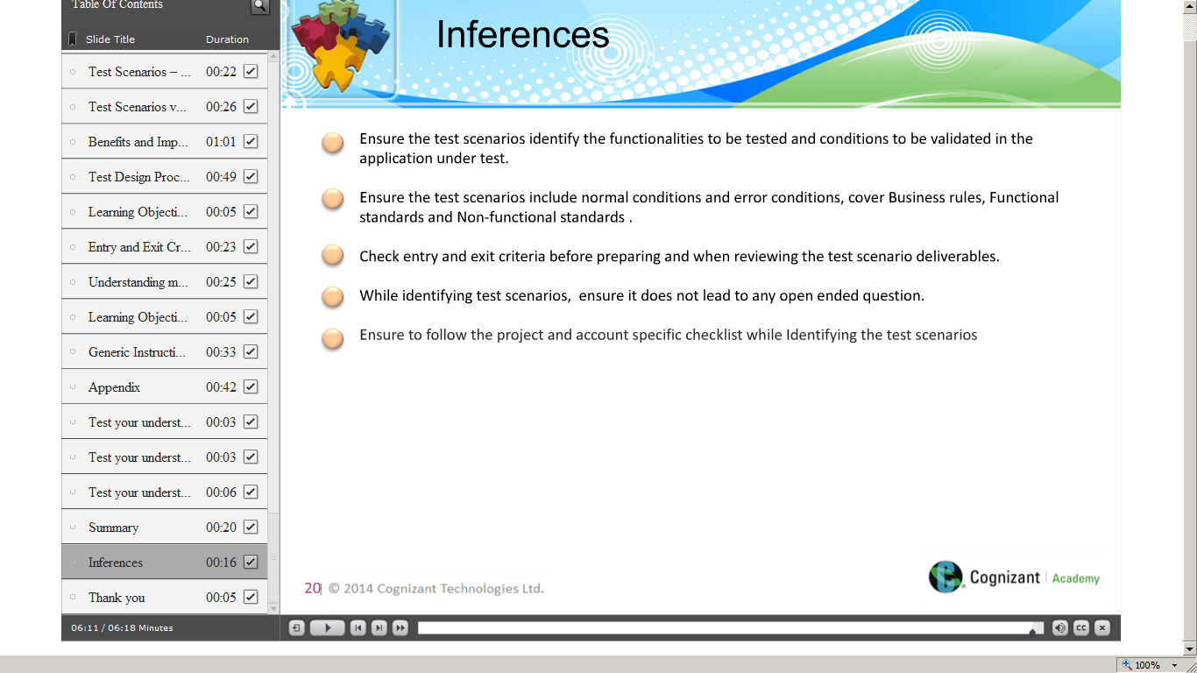](https://compass.learning.cognizant.com/elmprd/elearning/introduction_to_testsenarios_practitioner/introduction%20to%20test%20scenarios_practitioner.htm)

Part 2

[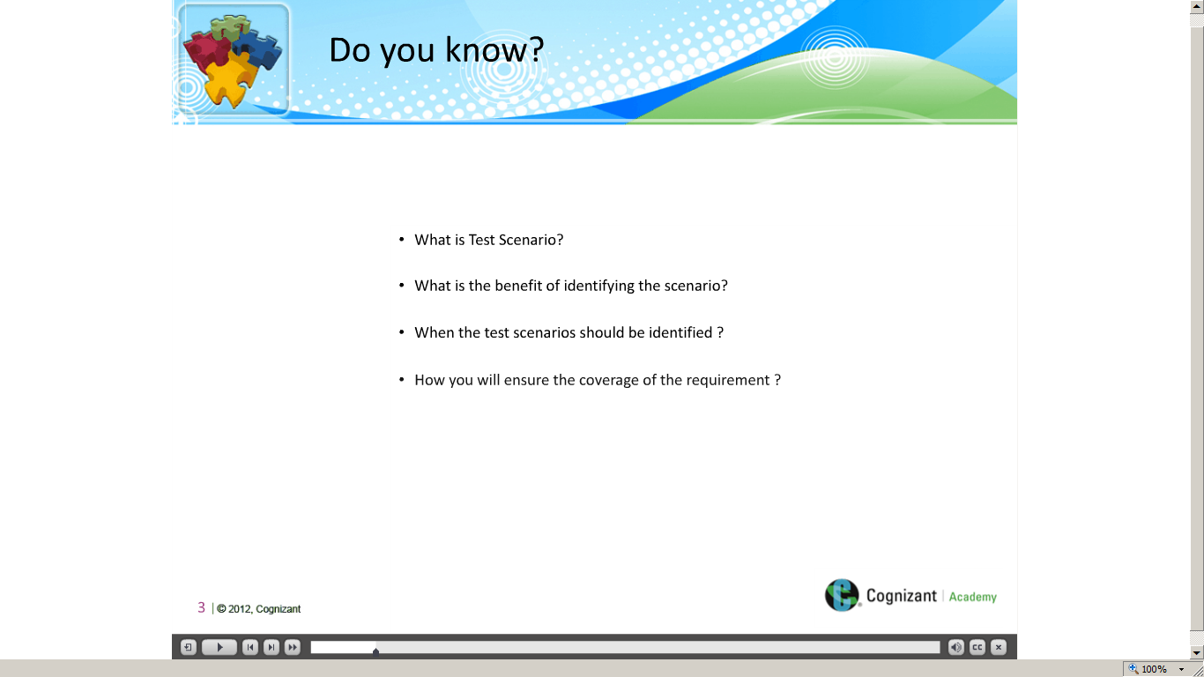](https://compass.learning.cognizant.com/elmprd/elearning/different_methods_to_identify_the_test_scenario/different%20methods%20to%20identify%20the%20test%20scenario.htm)

[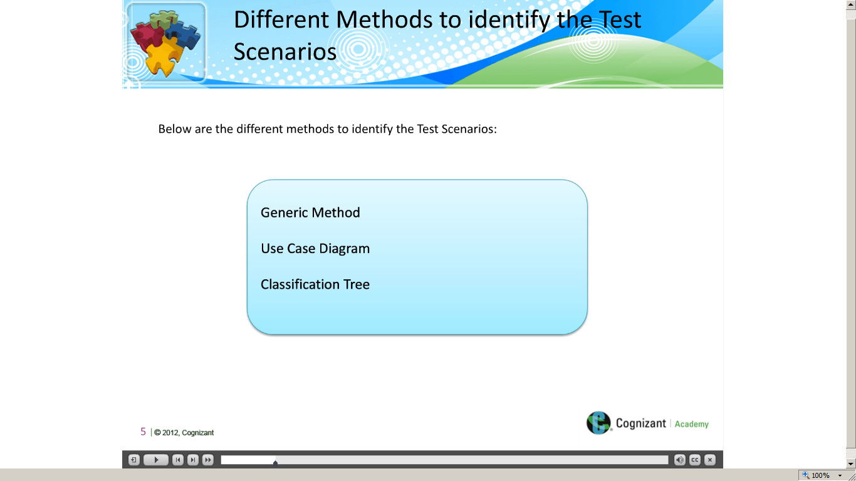](https://compass.learning.cognizant.com/elmprd/elearning/different_methods_to_identify_the_test_scenario/different%20methods%20to%20identify%20the%20test%20scenario.htm)

[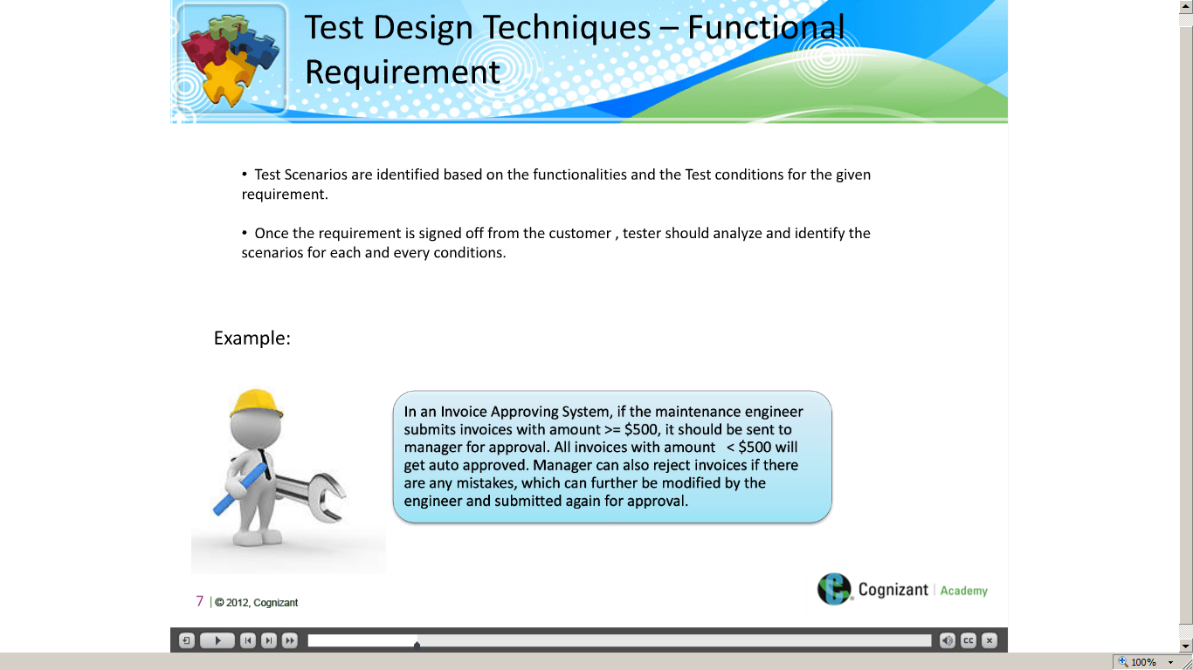](https://compass.learning.cognizant.com/elmprd/elearning/different_methods_to_identify_the_test_scenario/different%20methods%20to%20identify%20the%20test%20scenario.htm)

[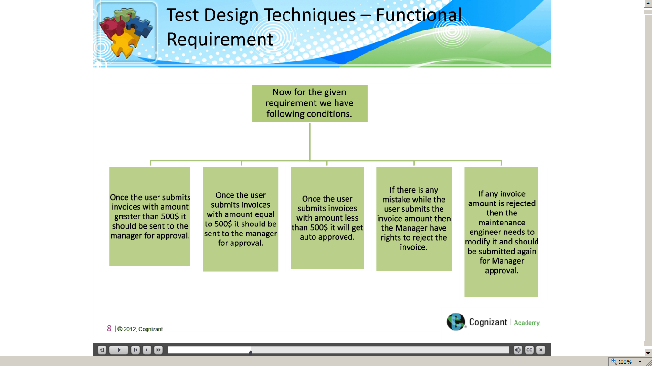](https://compass.learning.cognizant.com/elmprd/elearning/different_methods_to_identify_the_test_scenario/different%20methods%20to%20identify%20the%20test%20scenario.htm)

[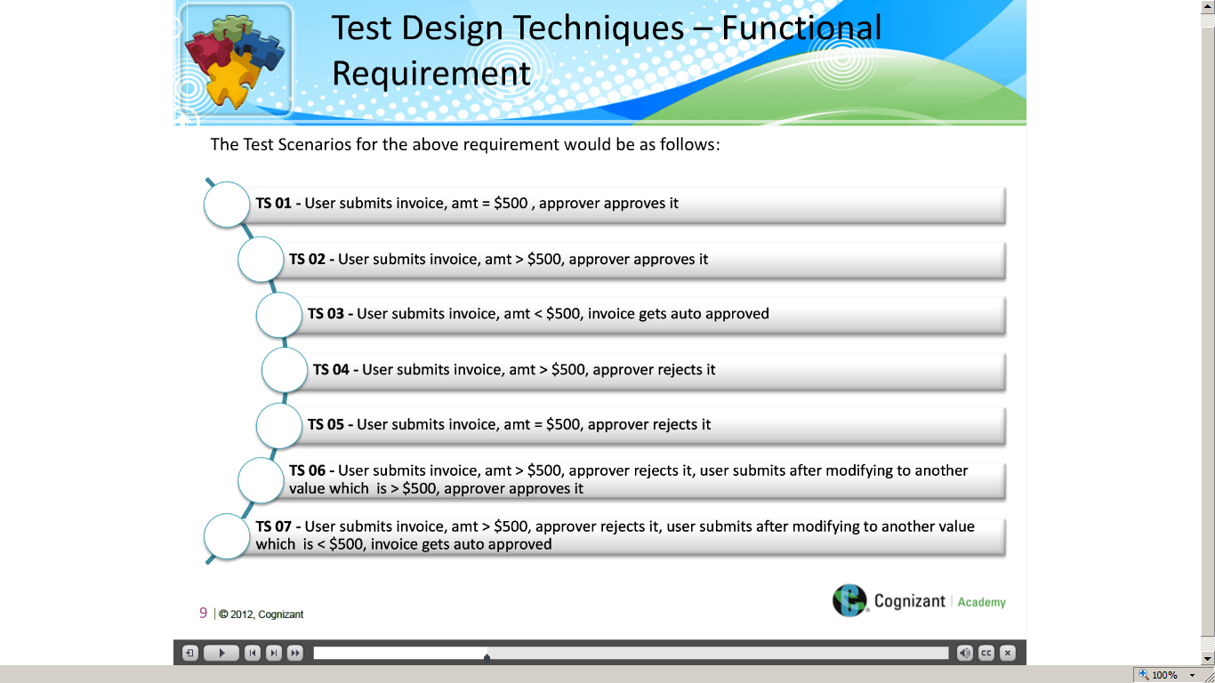](https://compass.learning.cognizant.com/elmprd/elearning/different_methods_to_identify_the_test_scenario/different%20methods%20to%20identify%20the%20test%20scenario.htm)

[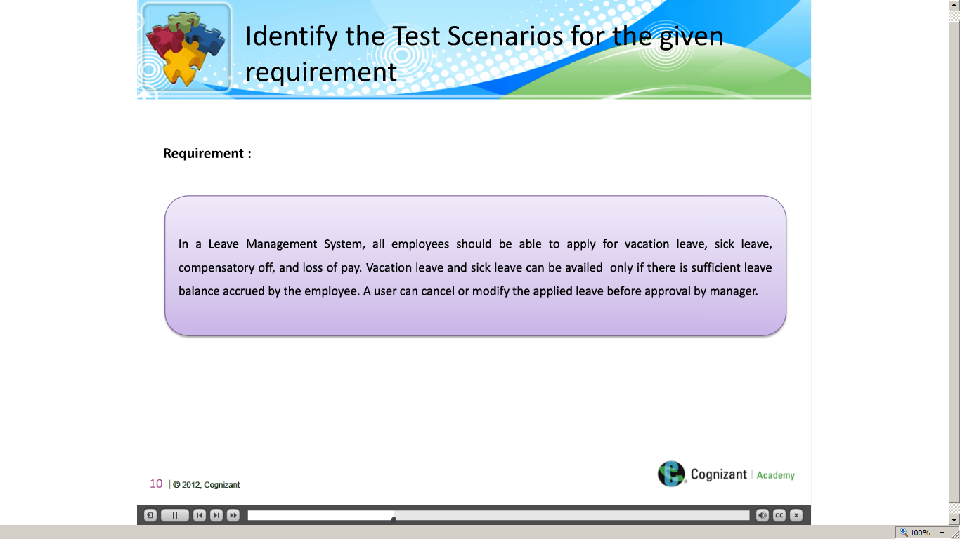](https://compass.learning.cognizant.com/elmprd/elearning/different_methods_to_identify_the_test_scenario/different%20methods%20to%20identify%20the%20test%20scenario.htm)

[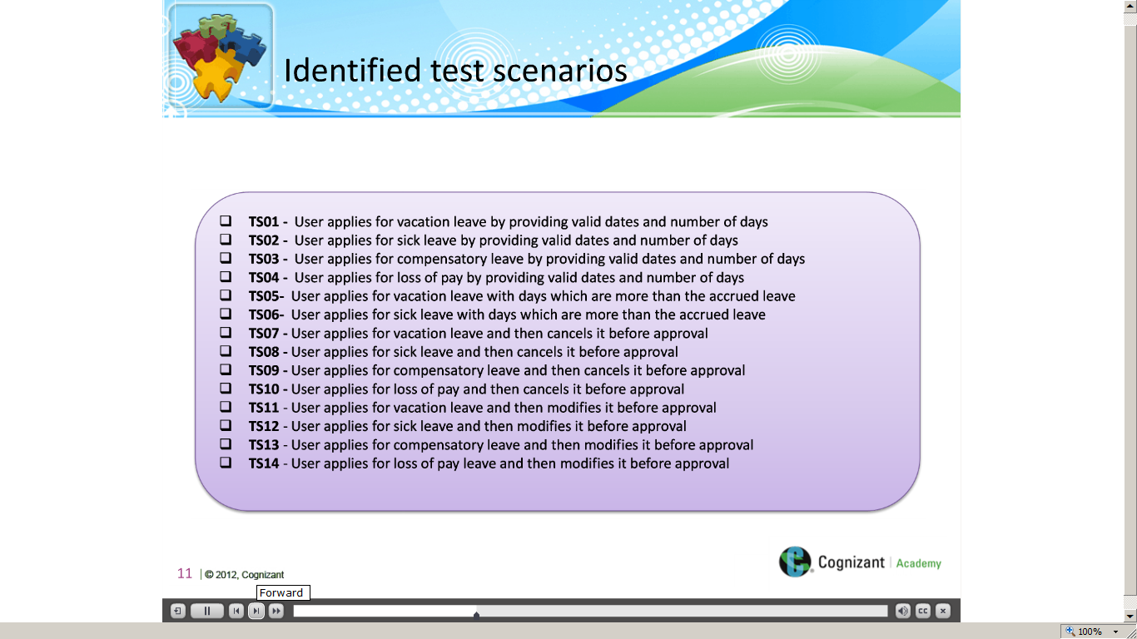](https://compass.learning.cognizant.com/elmprd/elearning/different_methods_to_identify_the_test_scenario/different%20methods%20to%20identify%20the%20test%20scenario.htm)

[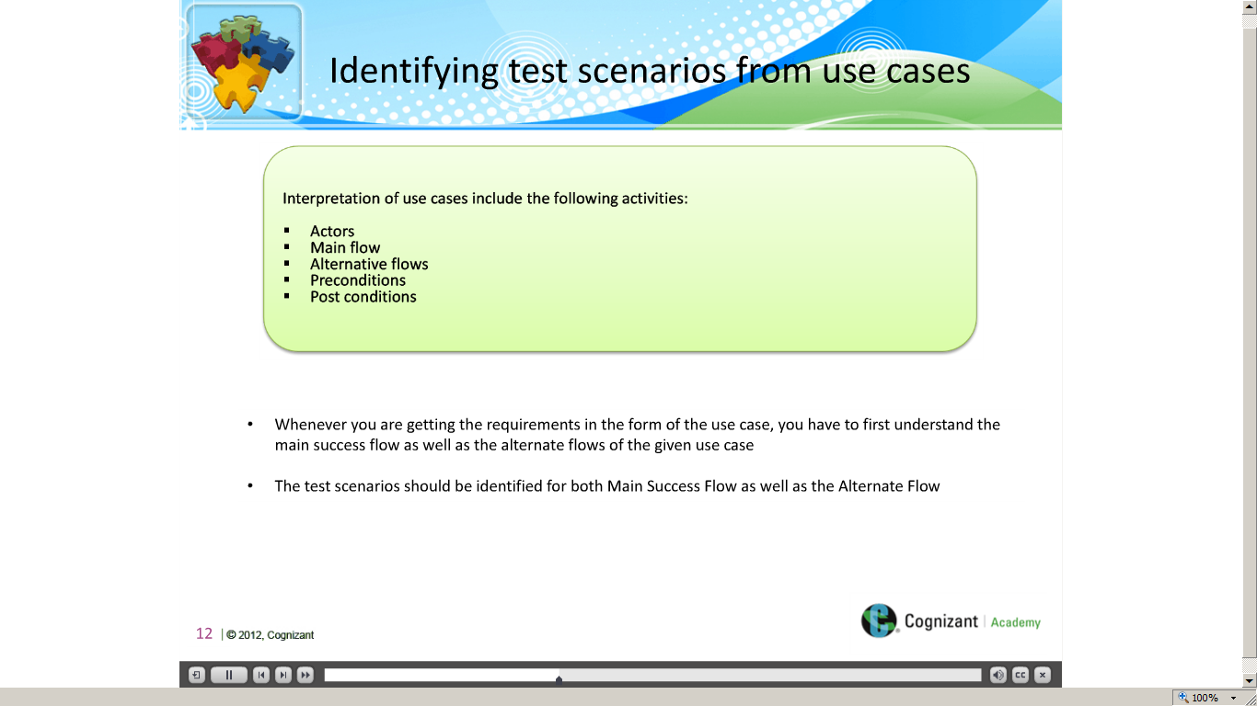](https://compass.learning.cognizant.com/elmprd/elearning/different_methods_to_identify_the_test_scenario/different%20methods%20to%20identify%20the%20test%20scenario.htm)

[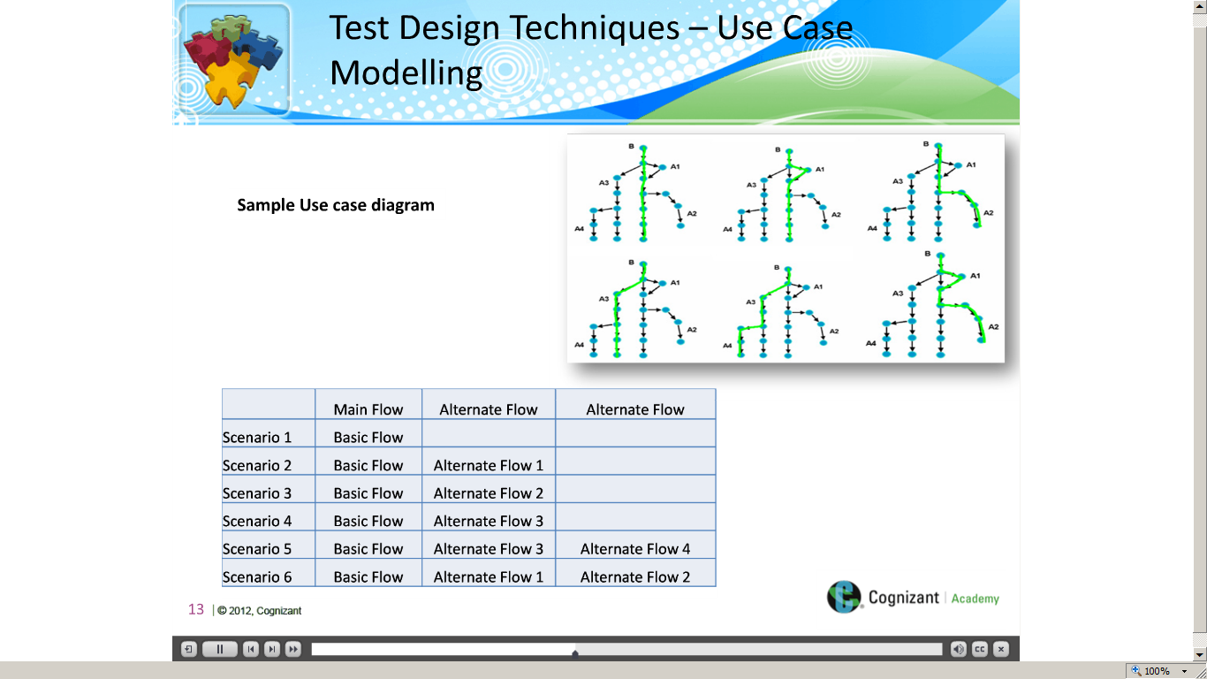](https://compass.learning.cognizant.com/elmprd/elearning/different_methods_to_identify_the_test_scenario/different%20methods%20to%20identify%20the%20test%20scenario.htm)

[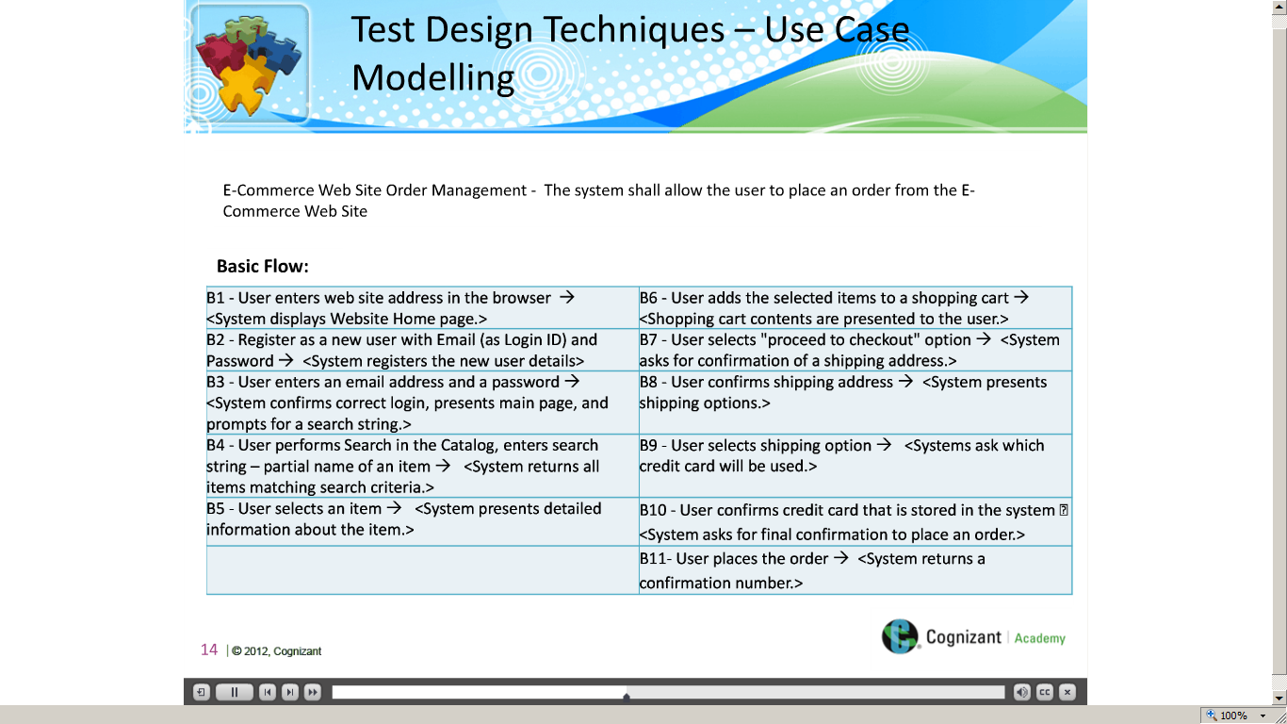](https://compass.learning.cognizant.com/elmprd/elearning/different_methods_to_identify_the_test_scenario/different%20methods%20to%20identify%20the%20test%20scenario.htm)

[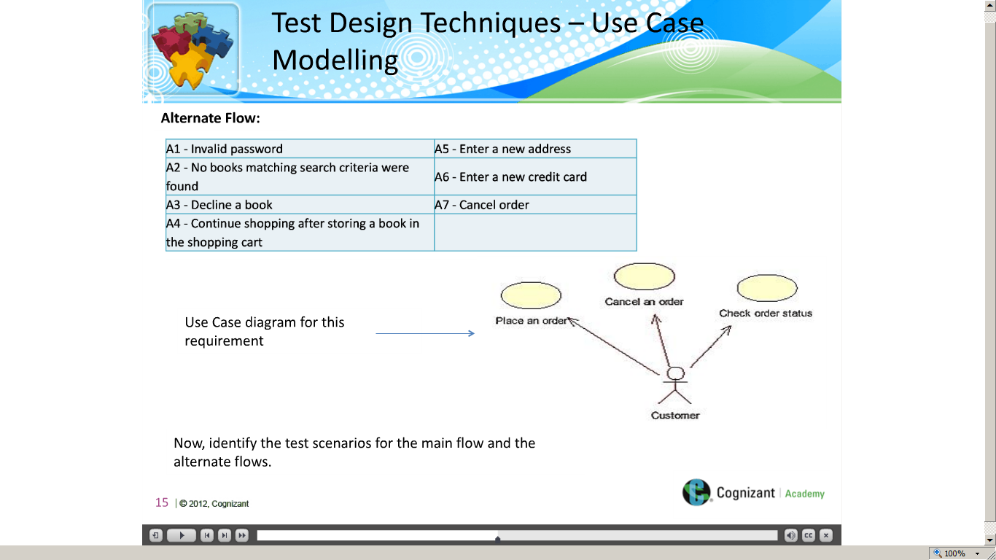](https://compass.learning.cognizant.com/elmprd/elearning/different_methods_to_identify_the_test_scenario/different%20methods%20to%20identify%20the%20test%20scenario.htm)

[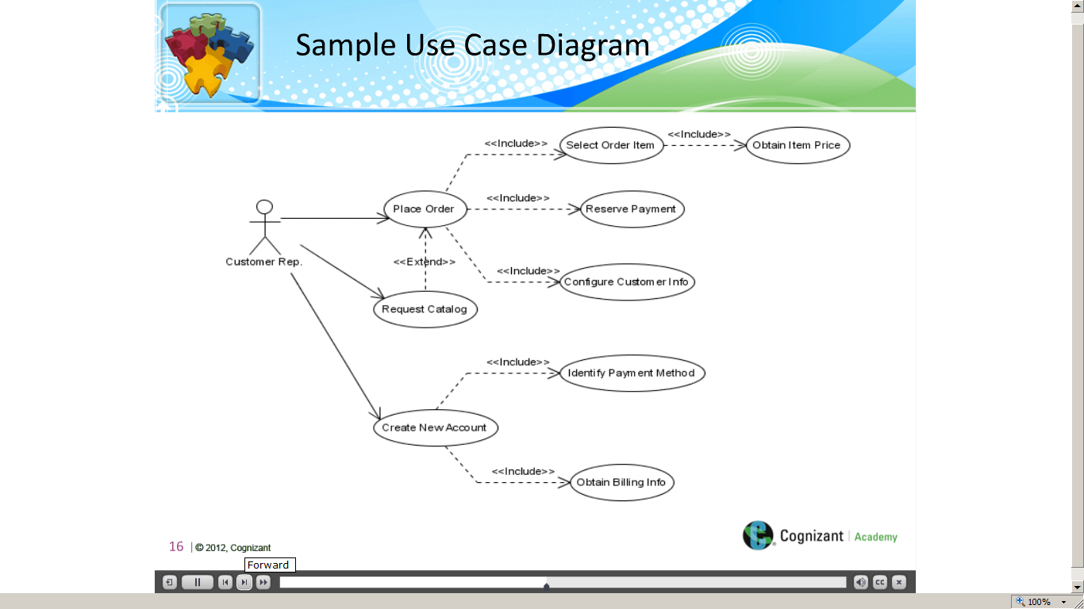](https://compass.learning.cognizant.com/elmprd/elearning/different_methods_to_identify_the_test_scenario/different%20methods%20to%20identify%20the%20test%20scenario.htm)

[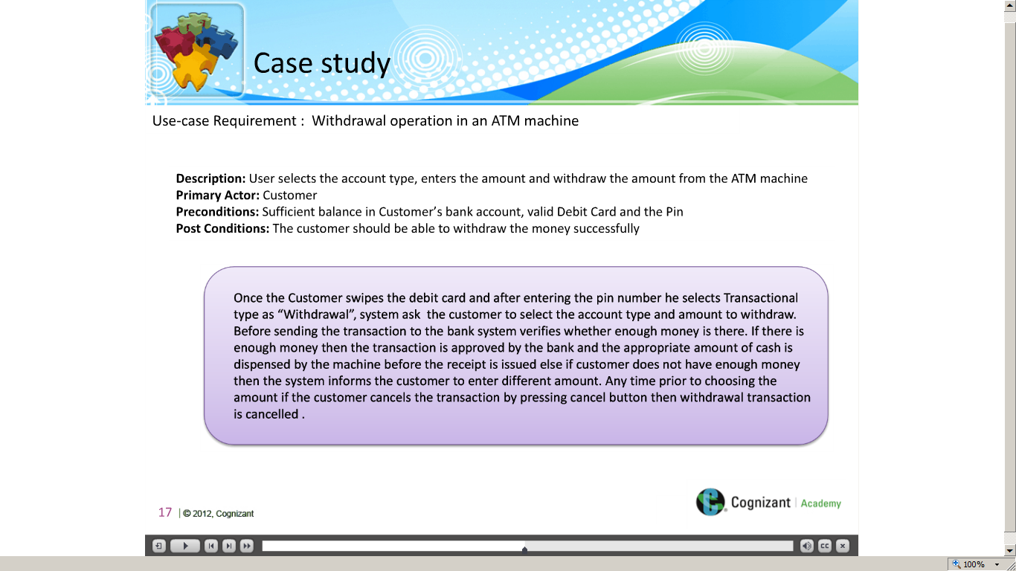](https://compass.learning.cognizant.com/elmprd/elearning/different_methods_to_identify_the_test_scenario/different%20methods%20to%20identify%20the%20test%20scenario.htm)

[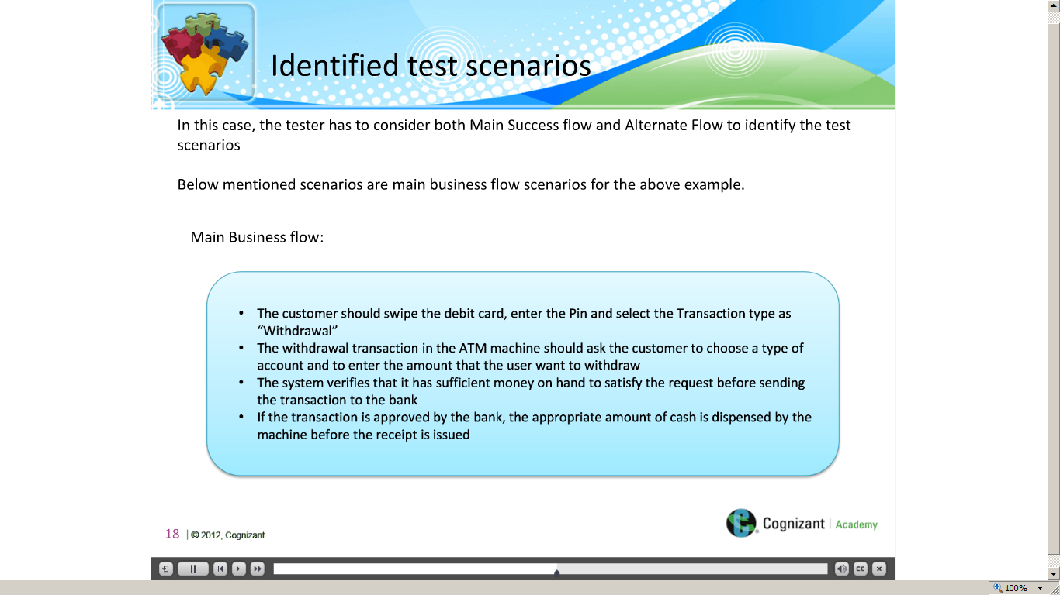](https://compass.learning.cognizant.com/elmprd/elearning/different_methods_to_identify_the_test_scenario/different%20methods%20to%20identify%20the%20test%20scenario.htm)

[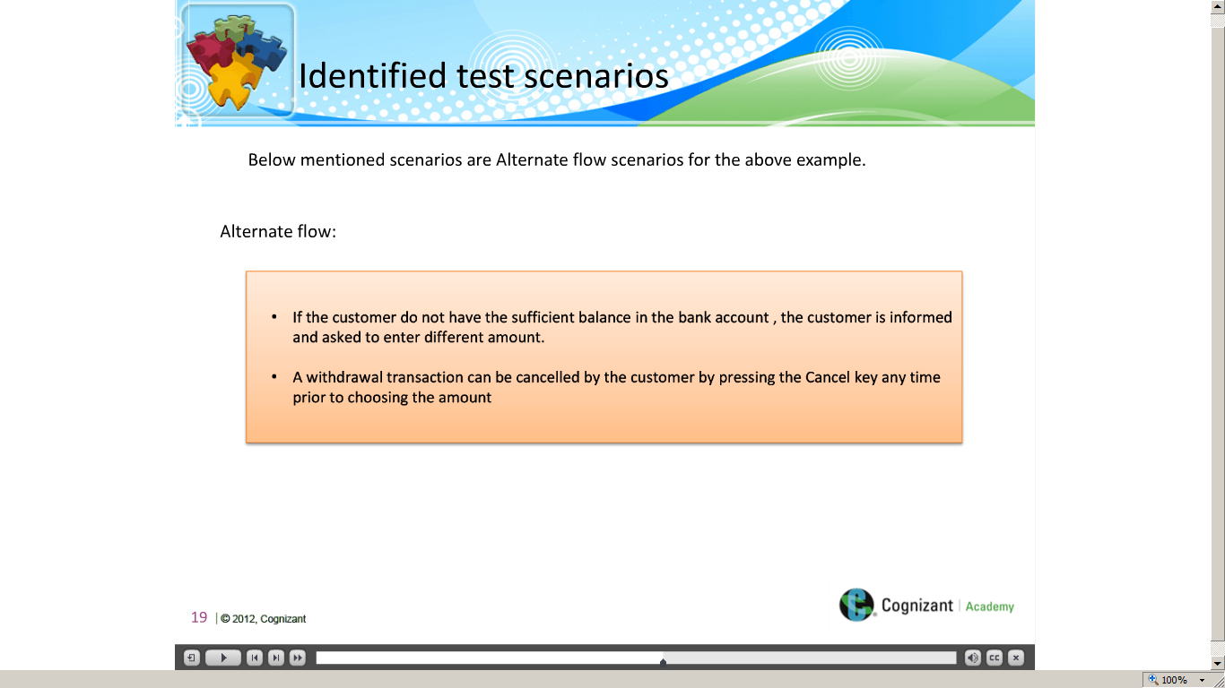](https://compass.learning.cognizant.com/elmprd/elearning/different_methods_to_identify_the_test_scenario/different%20methods%20to%20identify%20the%20test%20scenario.htm)

[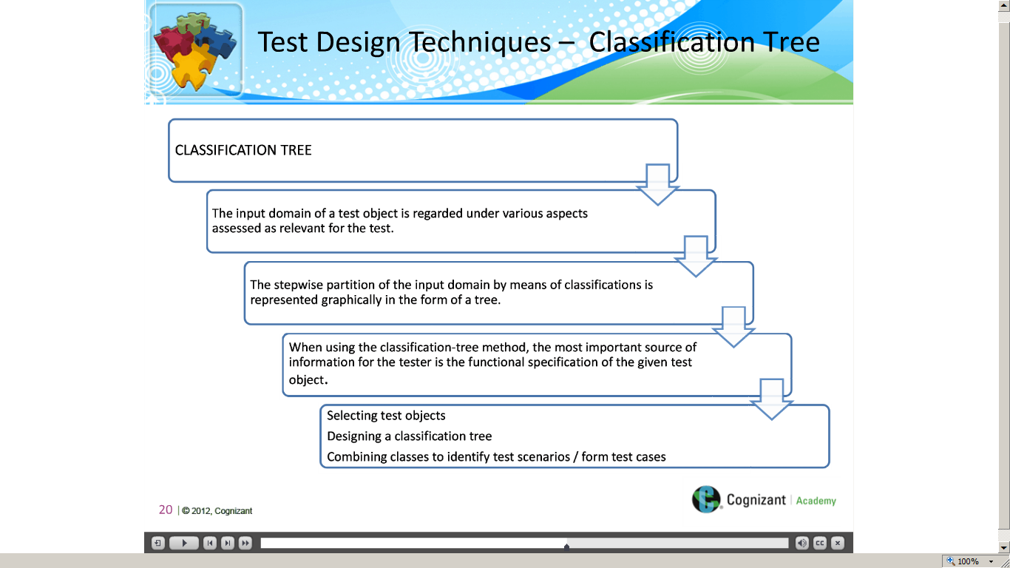](https://compass.learning.cognizant.com/elmprd/elearning/different_methods_to_identify_the_test_scenario/different%20methods%20to%20identify%20the%20test%20scenario.htm)

[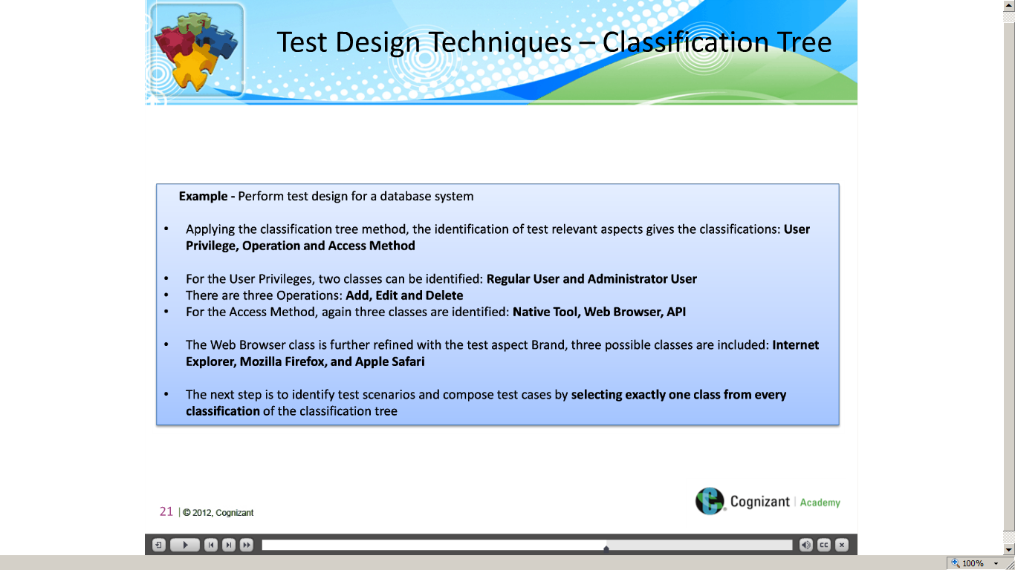](https://compass.learning.cognizant.com/elmprd/elearning/different_methods_to_identify_the_test_scenario/different%20methods%20to%20identify%20the%20test%20scenario.htm)

[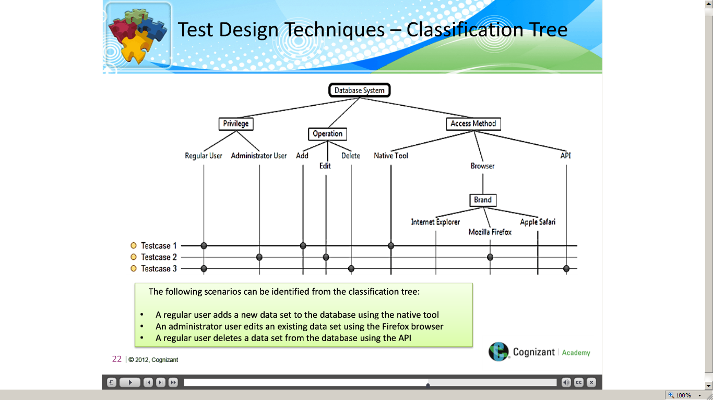](https://compass.learning.cognizant.com/elmprd/elearning/different_methods_to_identify_the_test_scenario/different%20methods%20to%20identify%20the%20test%20scenario.htm)

[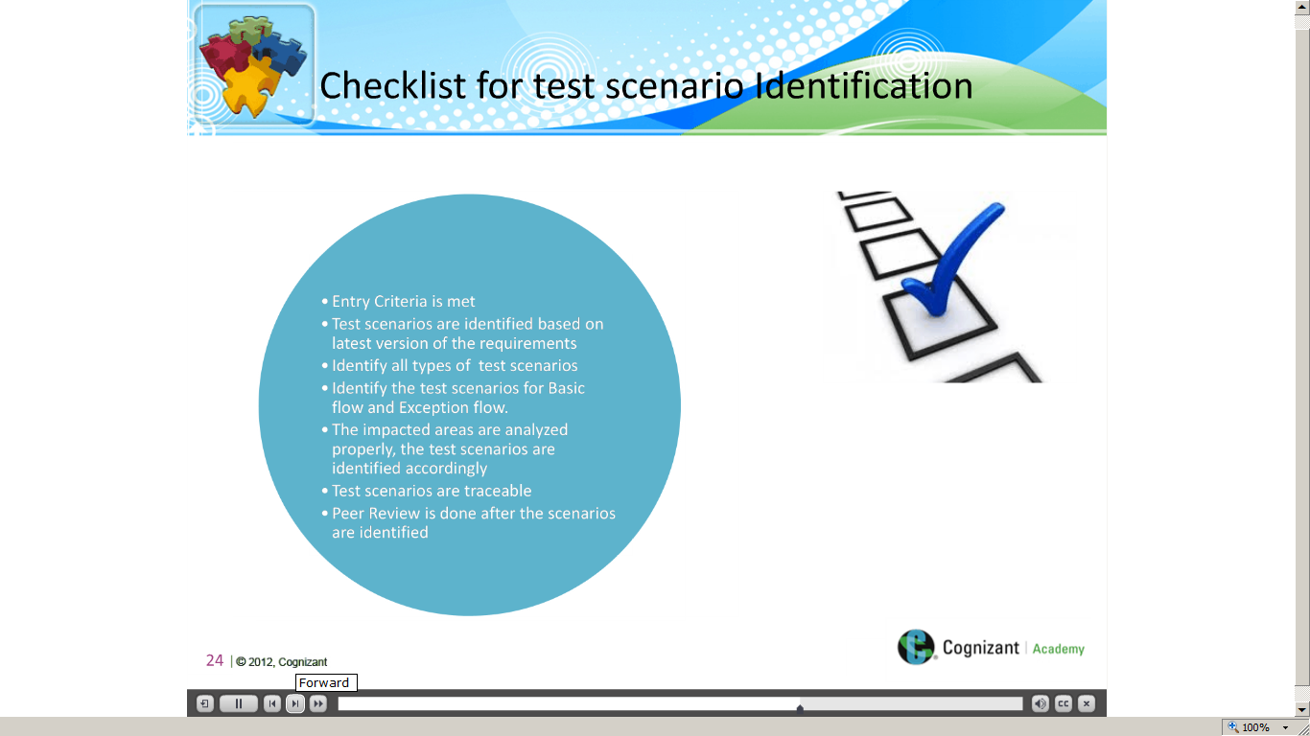](https://compass.learning.cognizant.com/elmprd/elearning/different_methods_to_identify_the_test_scenario/different%20methods%20to%20identify%20the%20test%20scenario.htm)

[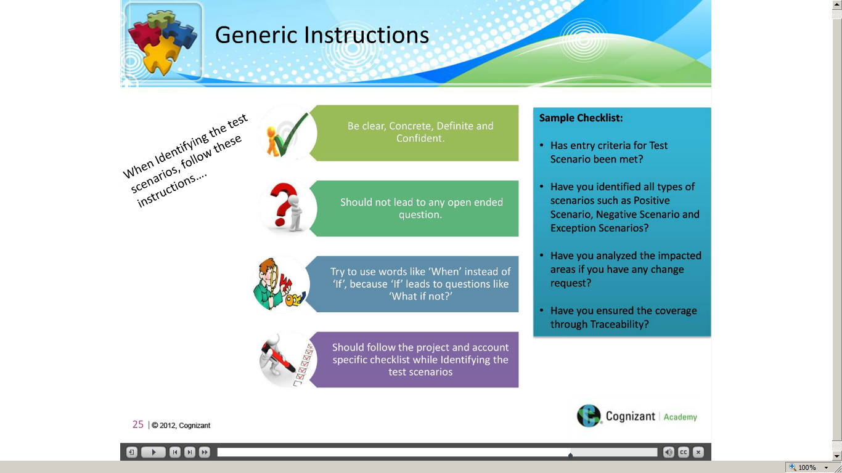](https://compass.learning.cognizant.com/elmprd/elearning/different_methods_to_identify_the_test_scenario/different%20methods%20to%20identify%20the%20test%20scenario.htm)

[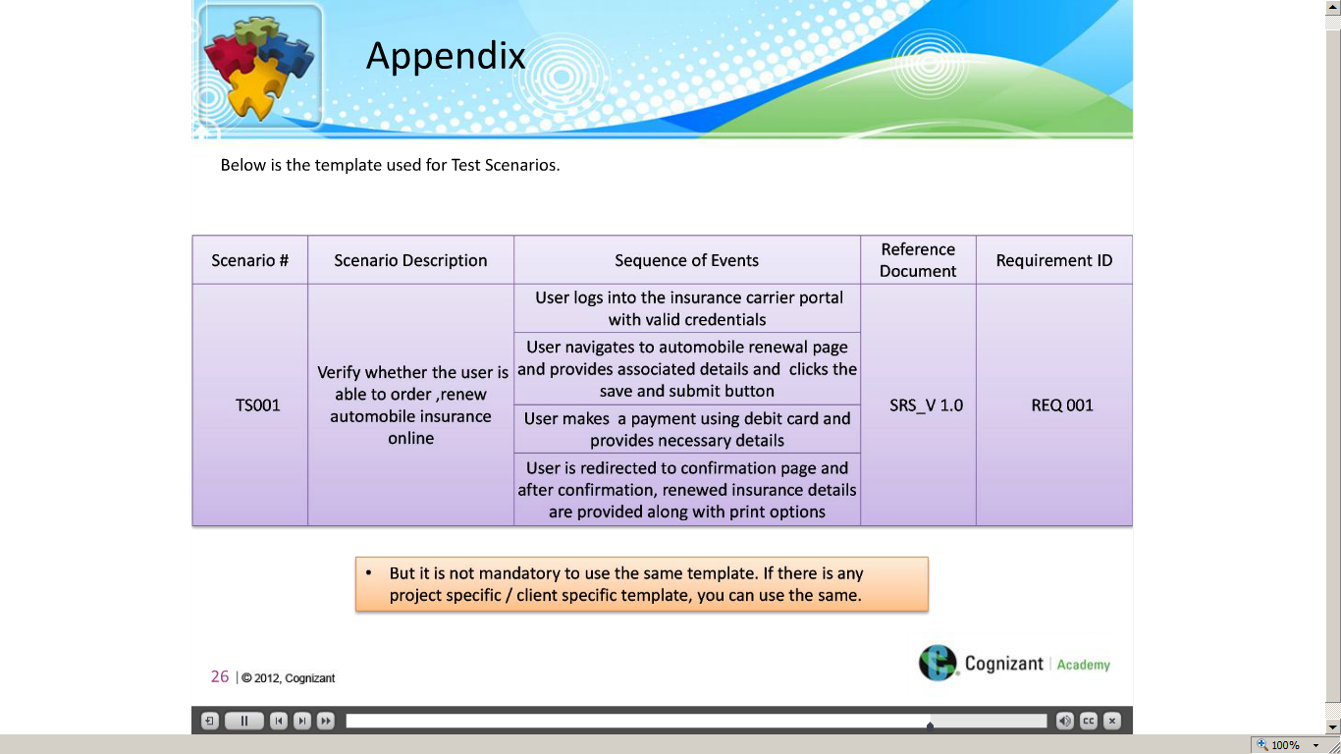](https://compass.learning.cognizant.com/elmprd/elearning/different_methods_to_identify_the_test_scenario/different%20methods%20to%20identify%20the%20test%20scenario.htm)

[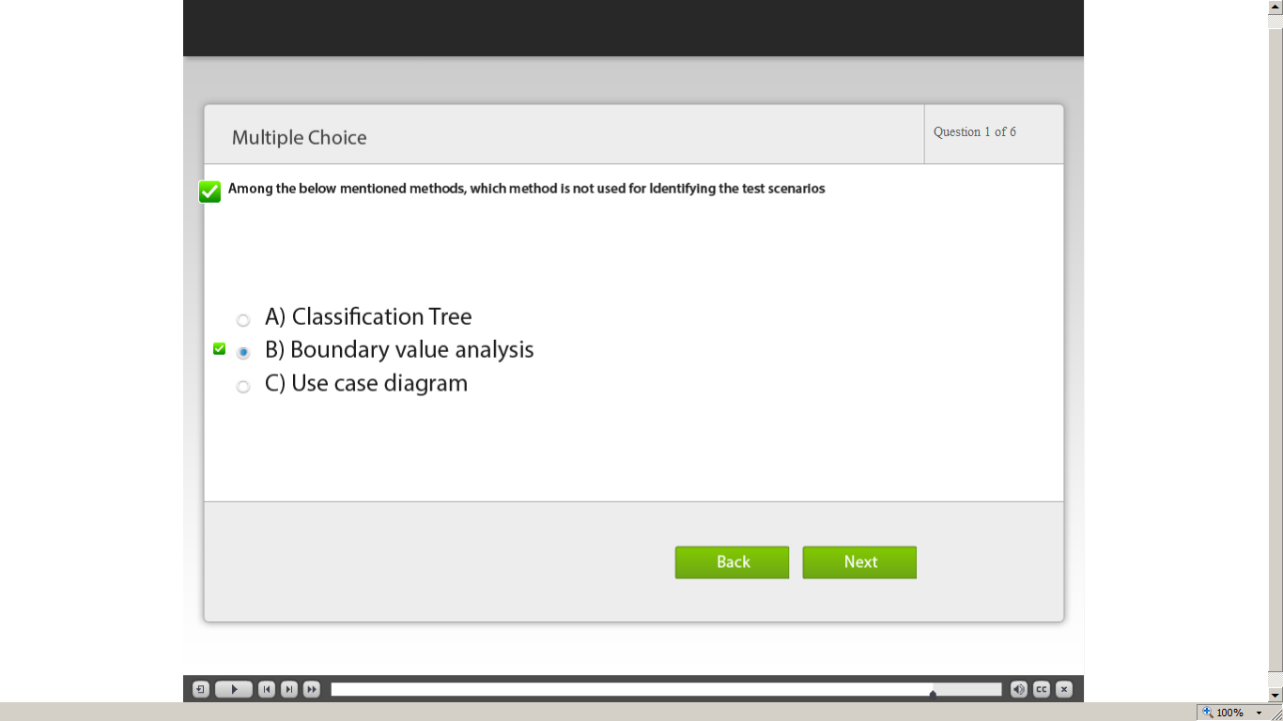](https://compass.learning.cognizant.com/elmprd/elearning/different_methods_to_identify_the_test_scenario/different%20methods%20to%20identify%20the%20test%20scenario.htm)

[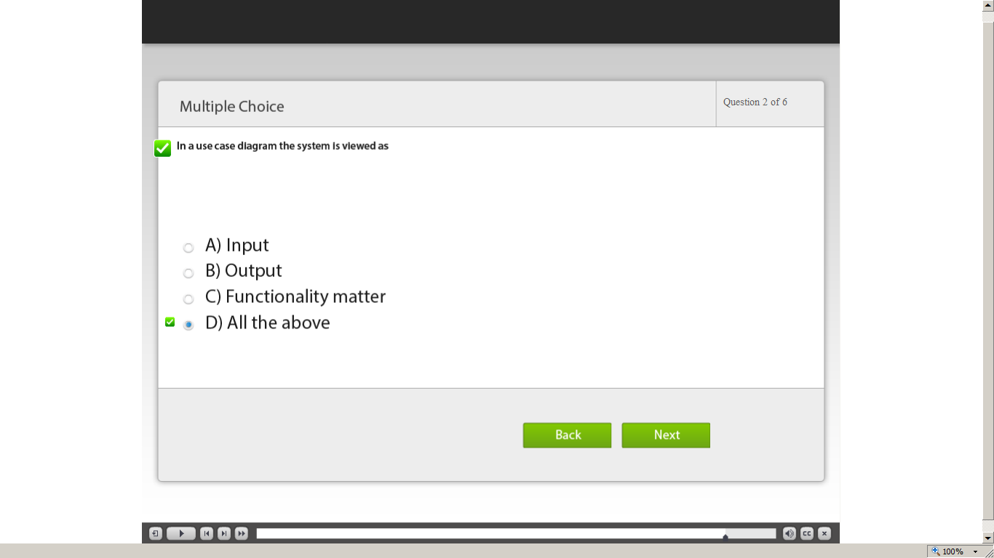](https://compass.learning.cognizant.com/elmprd/elearning/different_methods_to_identify_the_test_scenario/different%20methods%20to%20identify%20the%20test%20scenario.htm)

[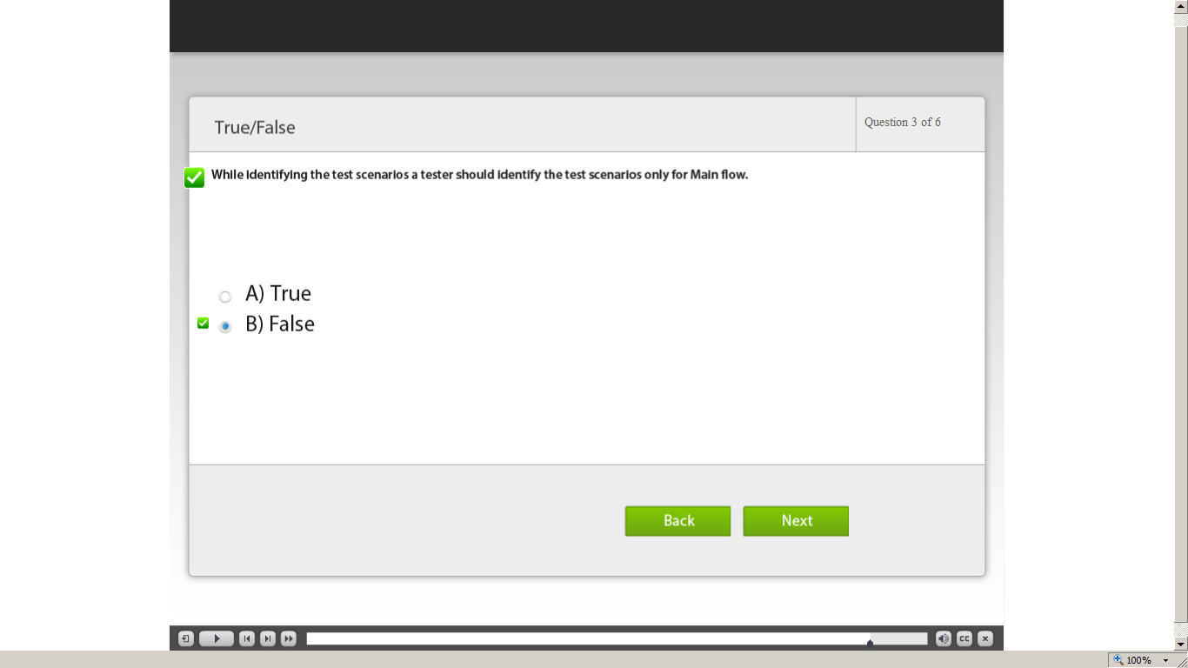](https://compass.learning.cognizant.com/elmprd/elearning/different_methods_to_identify_the_test_scenario/different%20methods%20to%20identify%20the%20test%20scenario.htm)

[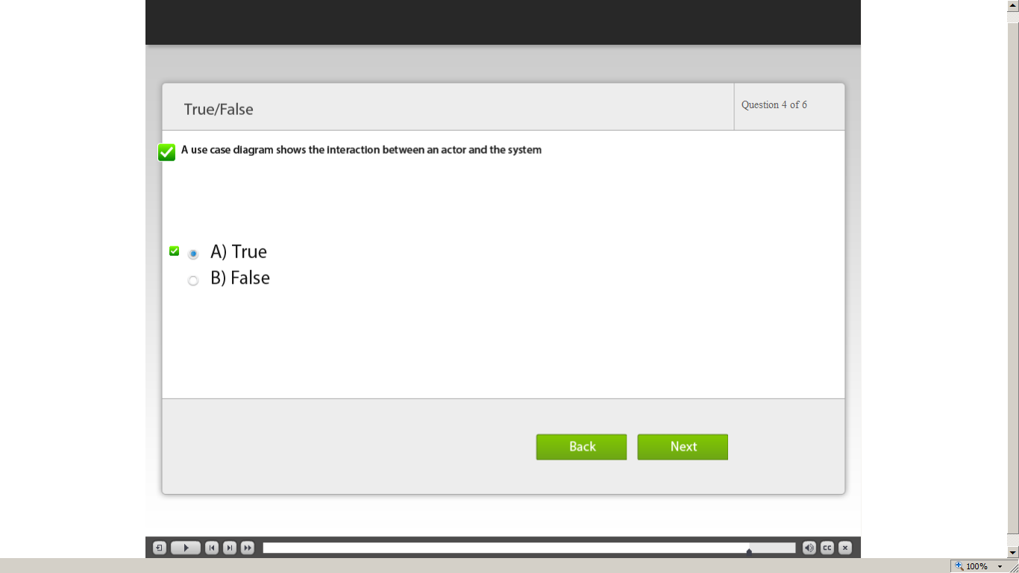](https://compass.learning.cognizant.com/elmprd/elearning/different_methods_to_identify_the_test_scenario/different%20methods%20to%20identify%20the%20test%20scenario.htm)

[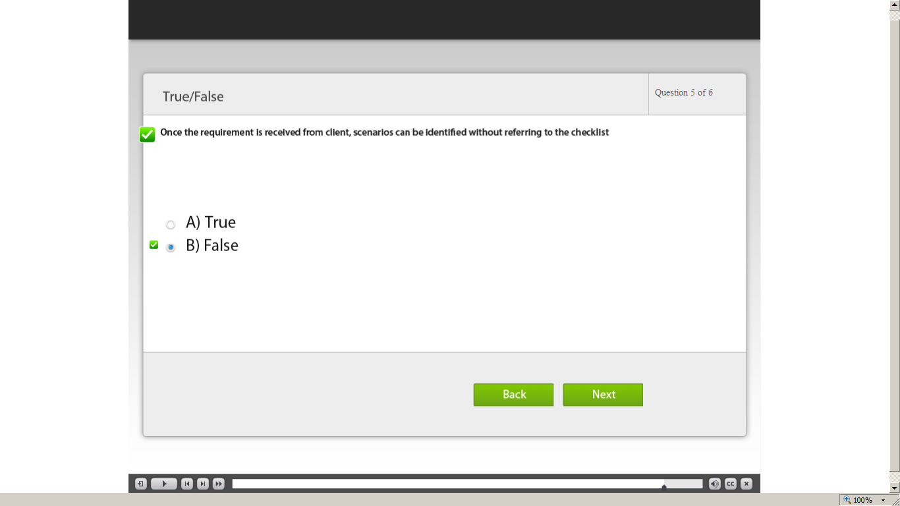](https://compass.learning.cognizant.com/elmprd/elearning/different_methods_to_identify_the_test_scenario/different%20methods%20to%20identify%20the%20test%20scenario.htm)

[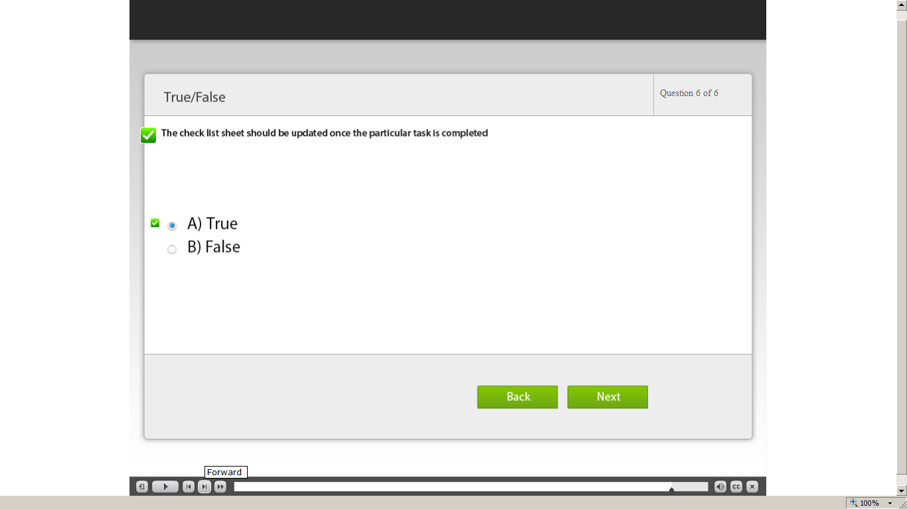](https://compass.learning.cognizant.com/elmprd/elearning/different_methods_to_identify_the_test_scenario/different%20methods%20to%20identify%20the%20test%20scenario.htm)

[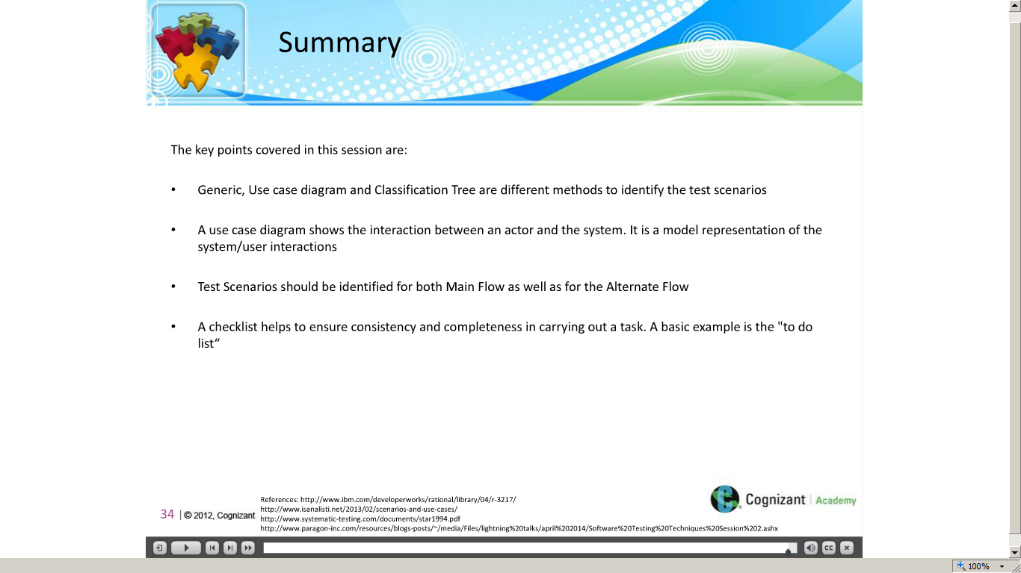](https://compass.learning.cognizant.com/elmprd/elearning/different_methods_to_identify_the_test_scenario/different%20methods%20to%20identify%20the%20test%20scenario.htm)

Part 3

[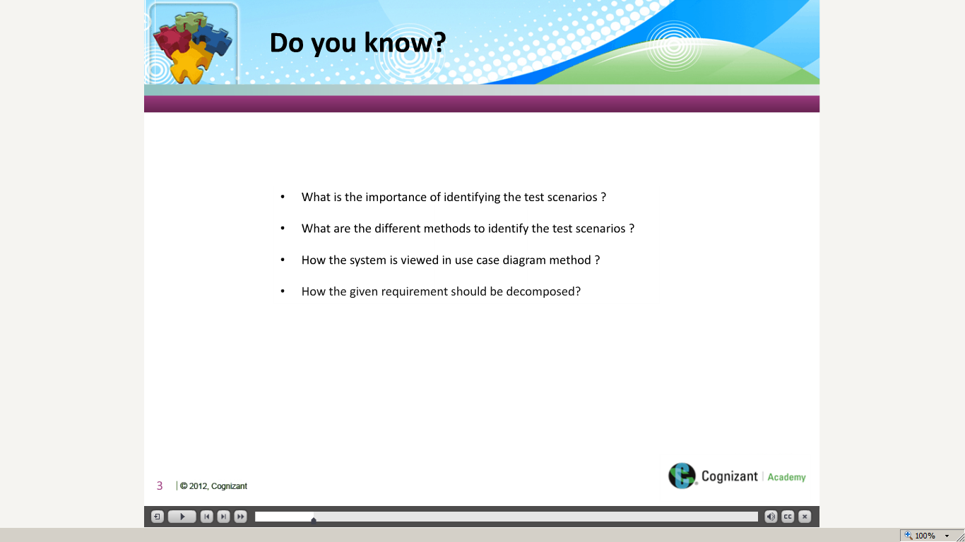](https://compass.learning.cognizant.com/elmprd/elearning/prioritization_of_test_scenarios/multiscreen.html)

[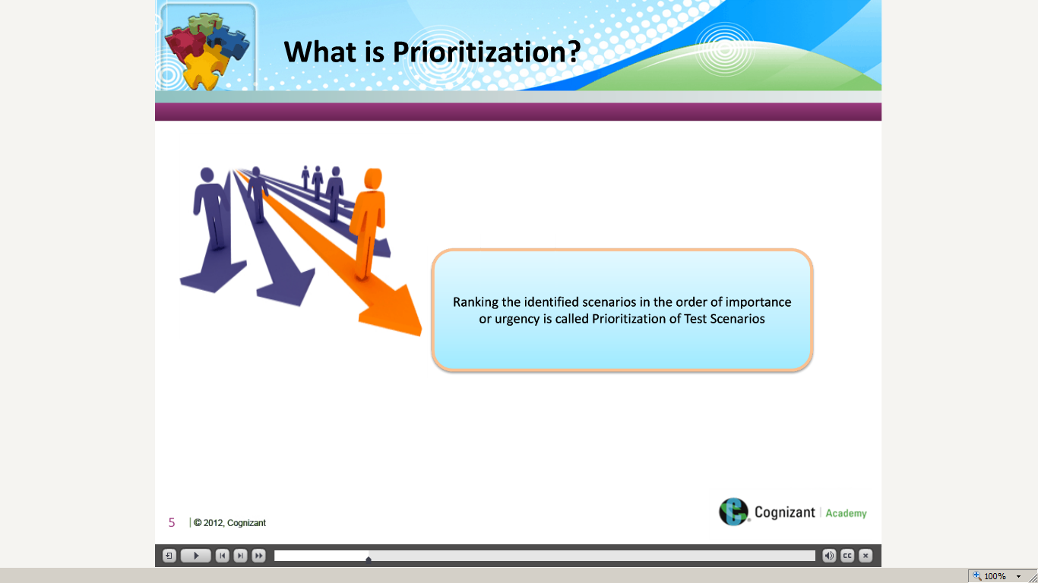](https://compass.learning.cognizant.com/elmprd/elearning/prioritization_of_test_scenarios/multiscreen.html)

[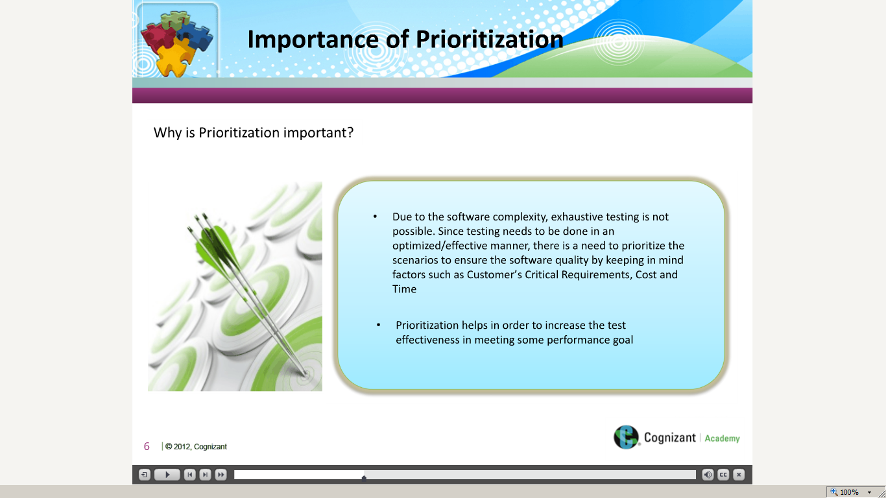](https://compass.learning.cognizant.com/elmprd/elearning/prioritization_of_test_scenarios/multiscreen.html)

[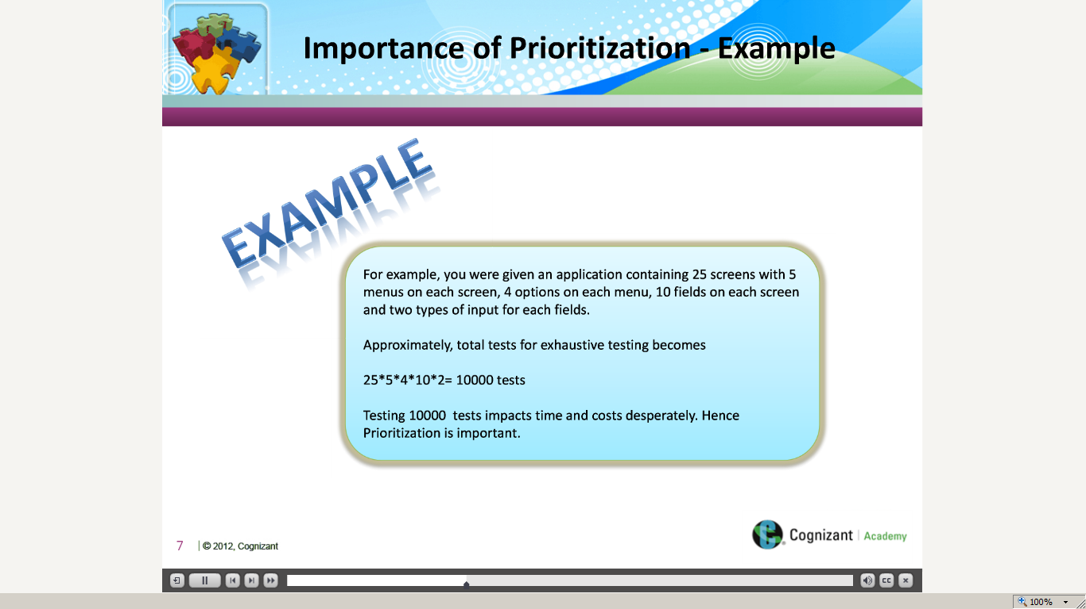](https://compass.learning.cognizant.com/elmprd/elearning/prioritization_of_test_scenarios/multiscreen.html)

[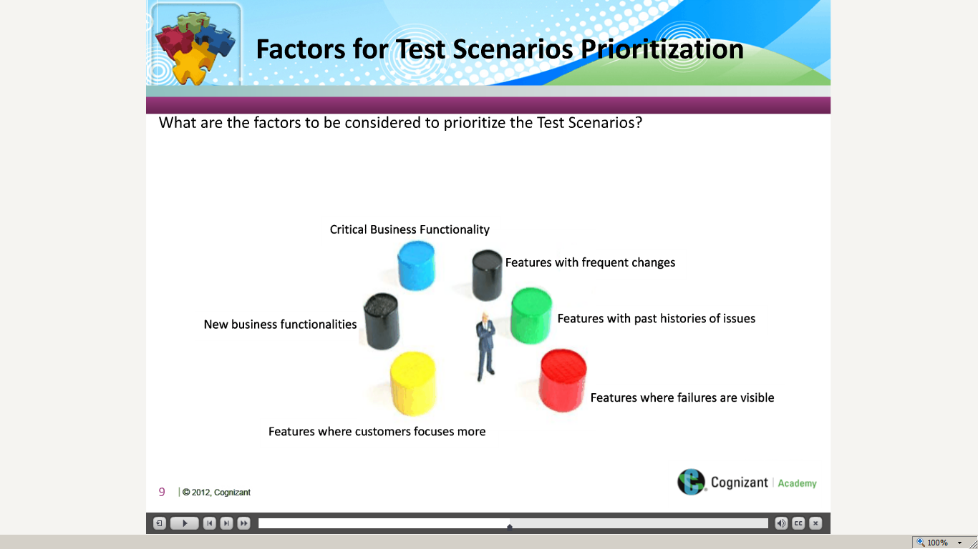](https://compass.learning.cognizant.com/elmprd/elearning/prioritization_of_test_scenarios/multiscreen.html)

[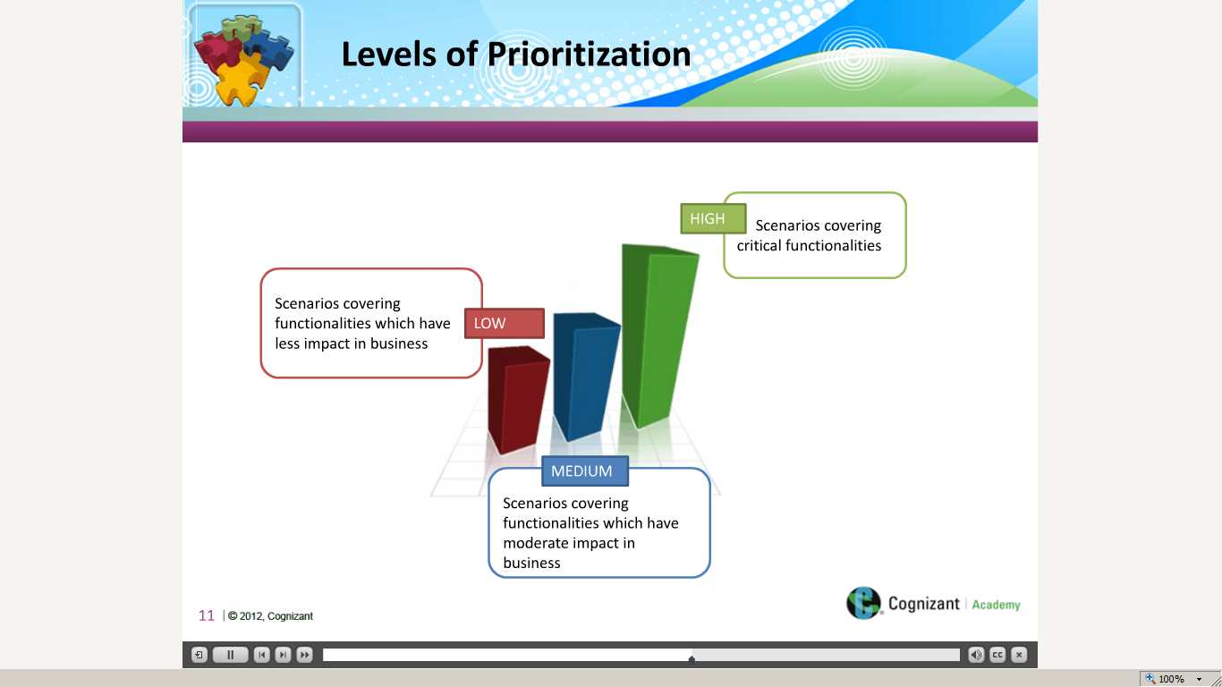](https://compass.learning.cognizant.com/elmprd/elearning/prioritization_of_test_scenarios/multiscreen.html)

[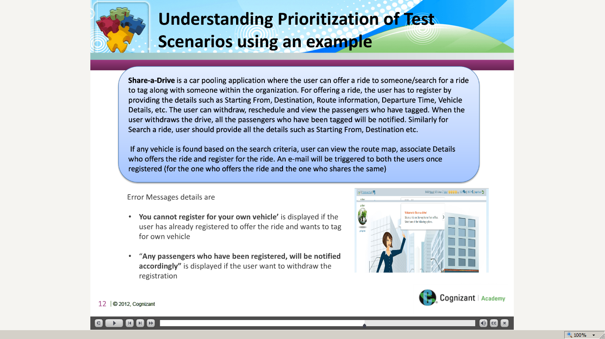](https://compass.learning.cognizant.com/elmprd/elearning/prioritization_of_test_scenarios/multiscreen.html)

[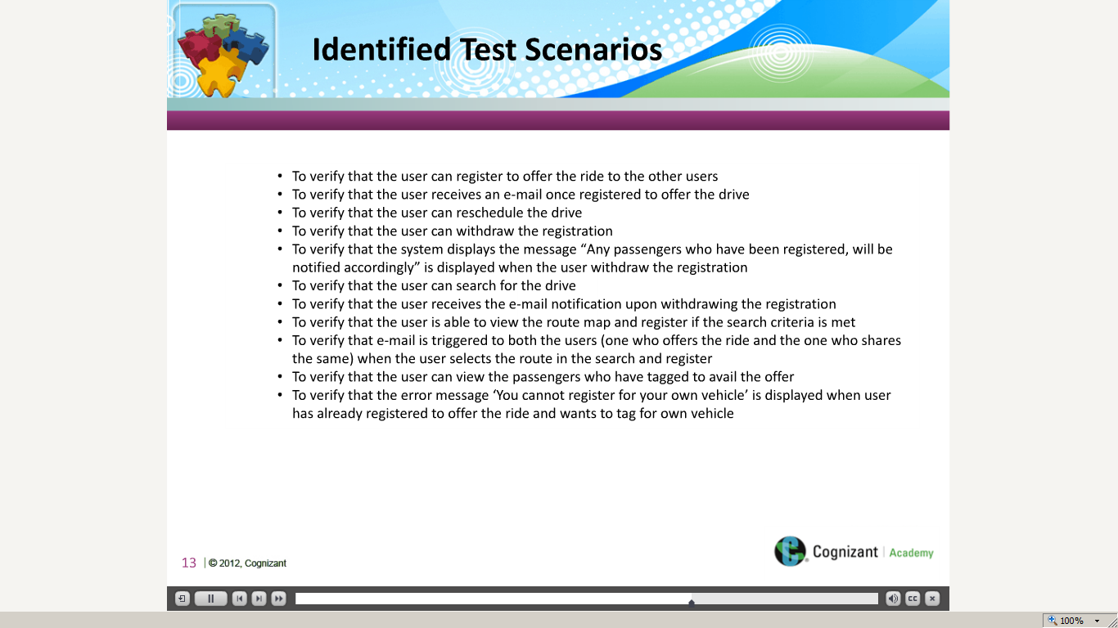](https://compass.learning.cognizant.com/elmprd/elearning/prioritization_of_test_scenarios/multiscreen.html)

[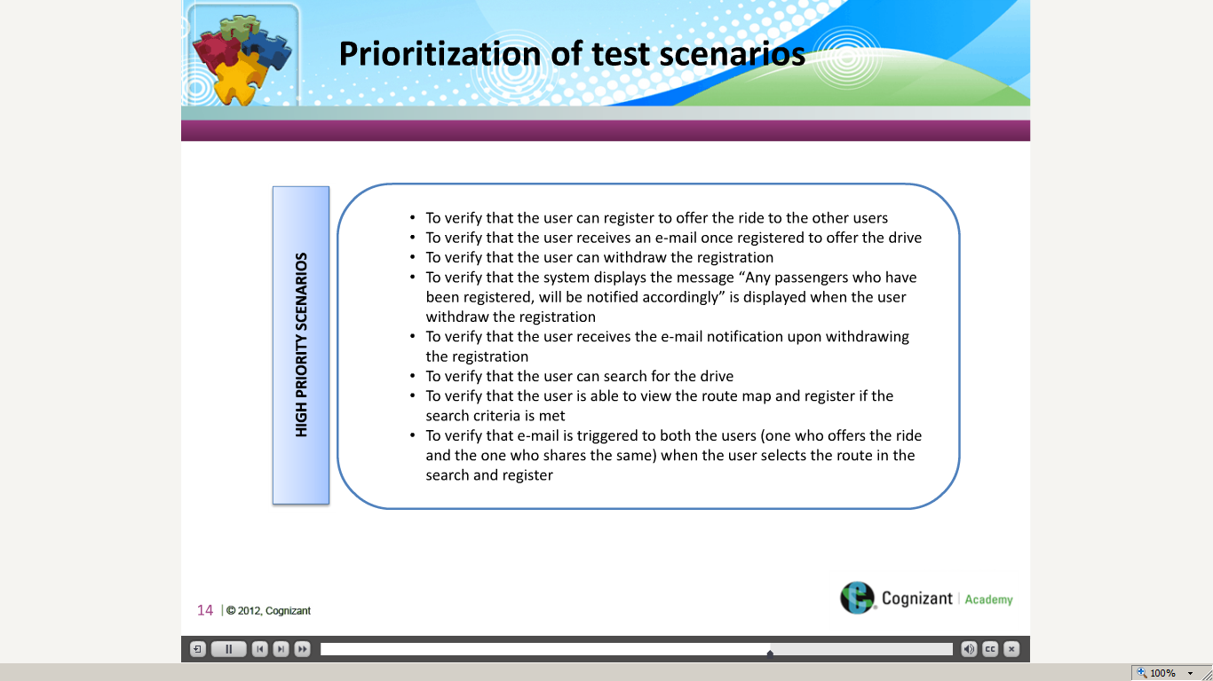](https://compass.learning.cognizant.com/elmprd/elearning/prioritization_of_test_scenarios/multiscreen.html)

[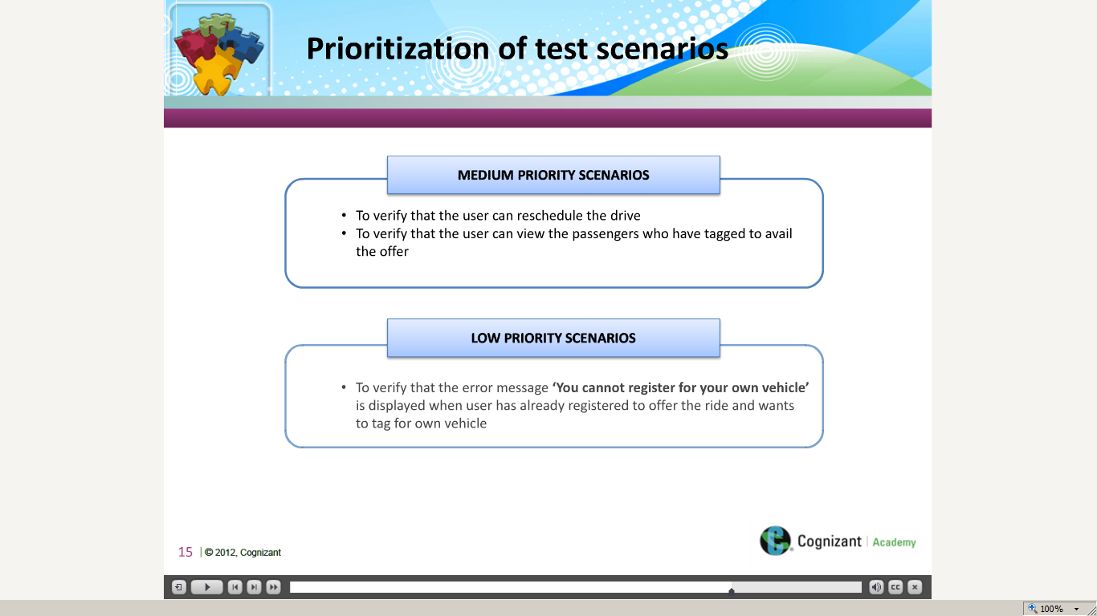](https://compass.learning.cognizant.com/elmprd/elearning/prioritization_of_test_scenarios/multiscreen.html)

[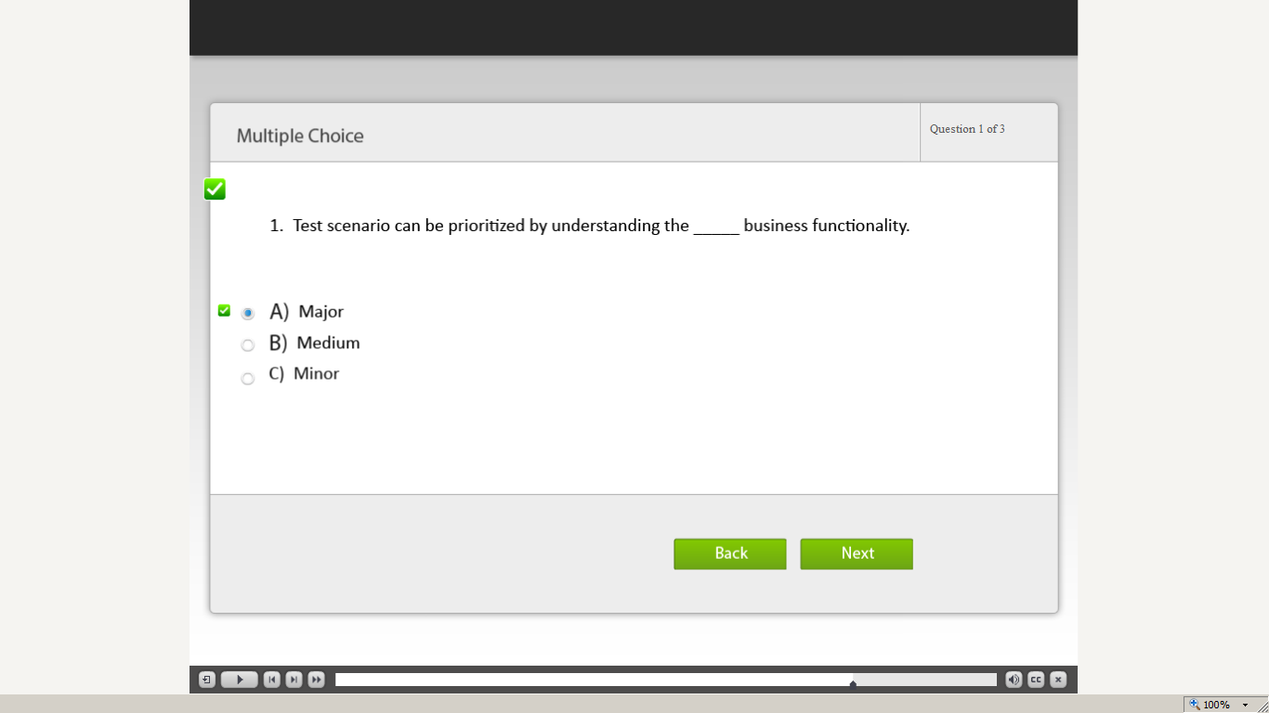](https://compass.learning.cognizant.com/elmprd/elearning/prioritization_of_test_scenarios/multiscreen.html)

[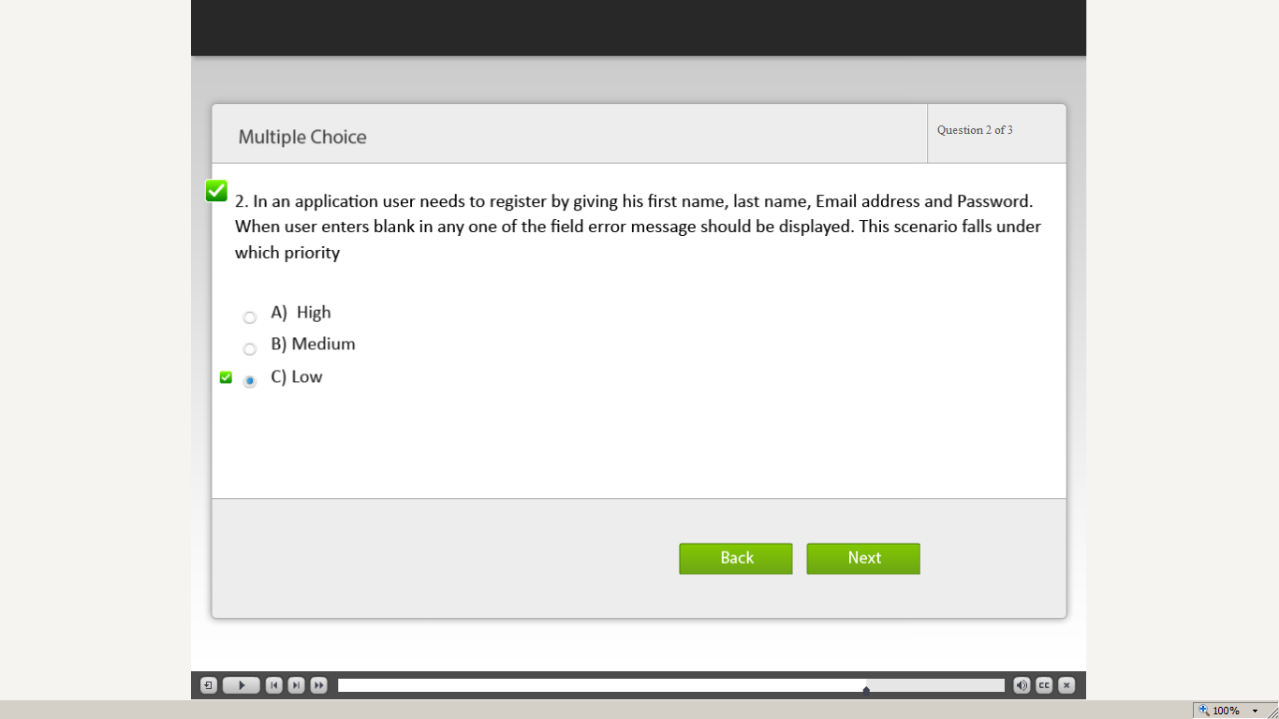](https://compass.learning.cognizant.com/elmprd/elearning/prioritization_of_test_scenarios/multiscreen.html)

[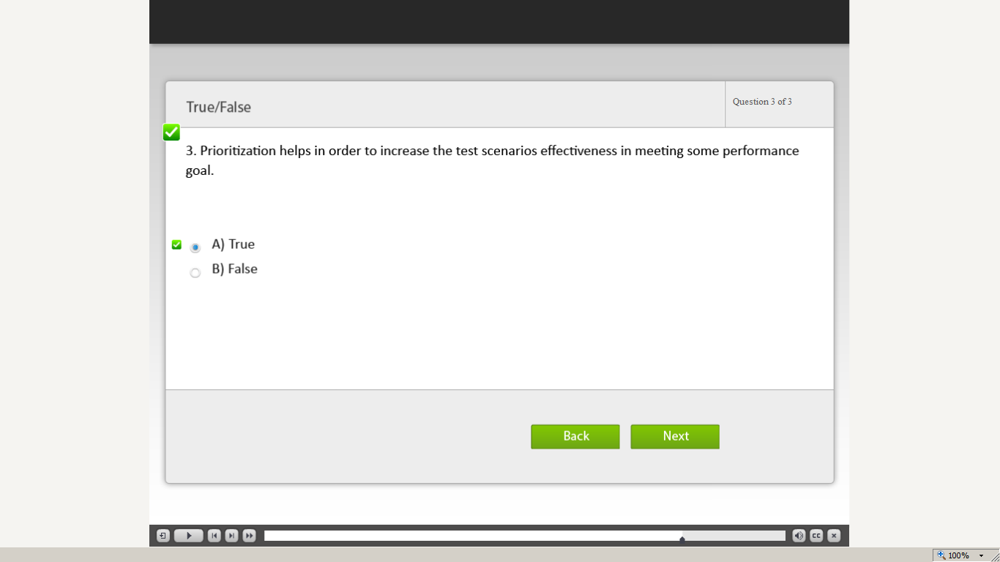](https://compass.learning.cognizant.com/elmprd/elearning/prioritization_of_test_scenarios/multiscreen.html)

[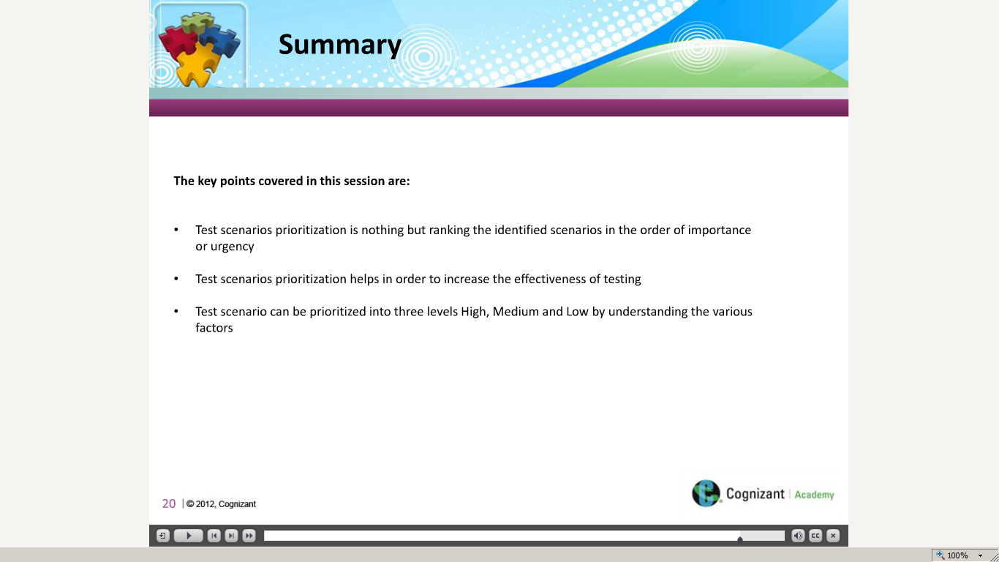](https://compass.learning.cognizant.com/elmprd/elearning/prioritization_of_test_scenarios/multiscreen.html)

[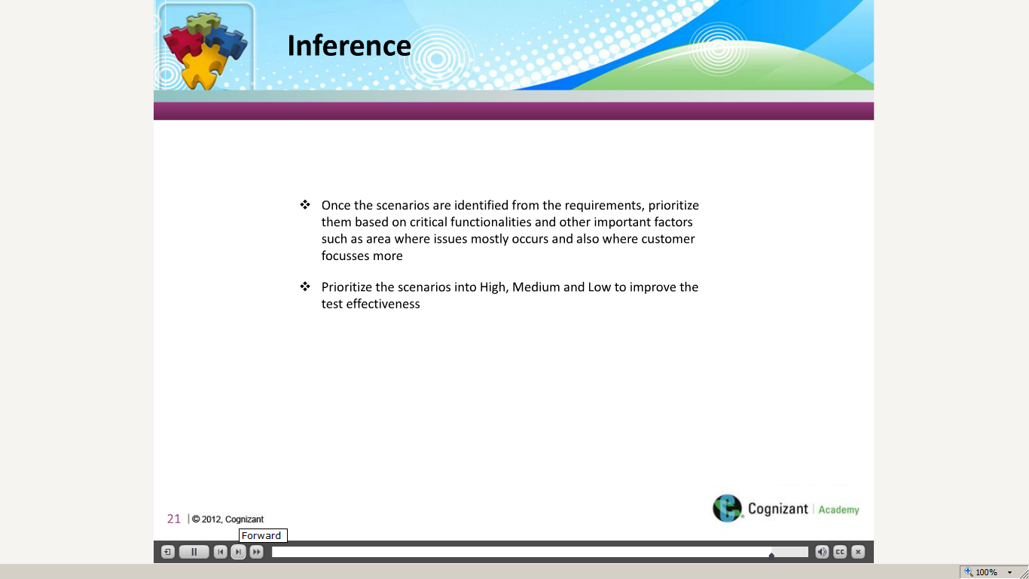](https://compass.learning.cognizant.com/elmprd/elearning/prioritization_of_test_scenarios/multiscreen.html)

Part 4

Case study